What staff member is making the most revenue?

A Summary

Here at Wally’s DVDs, we value the drive to be the best. We believe that everyone needs to get recognized for doing a good job. How do we determine who is doing the best job? What employee is bringing the most money or having the most transactions? This question deserves to get answered. This is why we are going to reward our top staff member with a $50.00 Amazon gift card. We will use the provided database to figure out who is our top selling employee. We know that we have lost a lot of good people to our competitor STREAM4U that is why we are going to do this competition. We are hoping that this will be a huge success and morale booster to show our employees that we really care about them. We will use this data not only to reward our top employee but to also train our other employees. We want all our employees to want to be the best.

A .1.1&2 Identify the specific fields that will be included in the detailed table and summary table.

* The stakeholders want to know staff members ids, their first and last names and their email addresses.
* They will also want to know each payment id and the date of each payment to verify the numbers.
* All the above info will be included in the detailed table report.
* The summary will include the Staff members id, full name, email address and number of sales they made.

A.2 Describe the specific fields used in the report.

- Summary Report called snapshot_summary

|  |  |
| --- | --- |
| DATA TYPE | VARIABLE NAME |
| SERIAL | staff_id |
| VARCHAR (500) | email |
| VARCHAR (200) | employee_name |
| INT | grand_total_sales |

* Detailed Report called thorough_report

|  |  |
| --- | --- |
| DATA TYPE | VARIABLE NAME |
| INT | payment_id |
| TIMESTAMP | payment_date |
| INT | staff_id |
| VARCHAR(100) | first_name |
| VARCHAR(200) | last_name |
| VARCHAR(300) | email |

A.3.1&2 Identify at least 2 tables for the detailed table and summary table that will be needed to provide the necessary data.

- The detailed table will use data from the Payment table and the Staff table.

* The summary table will use data from both the Payment and Staff table as well.
* There won’t be a need to use any other tables since this will provide the information I will need; however I will need to join both tables together because I will need to use both tables.

A.4 Identify at least 1 field in the detailed table that will require a custom transformation with a user defined function and explain why it should be transformed.

- I will make it easier to read by making the first and last names into 1 column named employee name.

- Each staff member will be grouped to count how many DVDs were sold.

- They will also be sorted in a descending order, so we are able to see the best on top.

A.5 Explain the different uses as a business is concerned between the Detailed Table and the Summary Table.

- The detailed report will tell us exactly when a payment was.

- We will be able to determine and watch when customers buy from our top selling staff employee.

- Based off the date we will be able to watch the tapes and determine what our employee did to then train our other employees.

- This is what the detailed table will look like

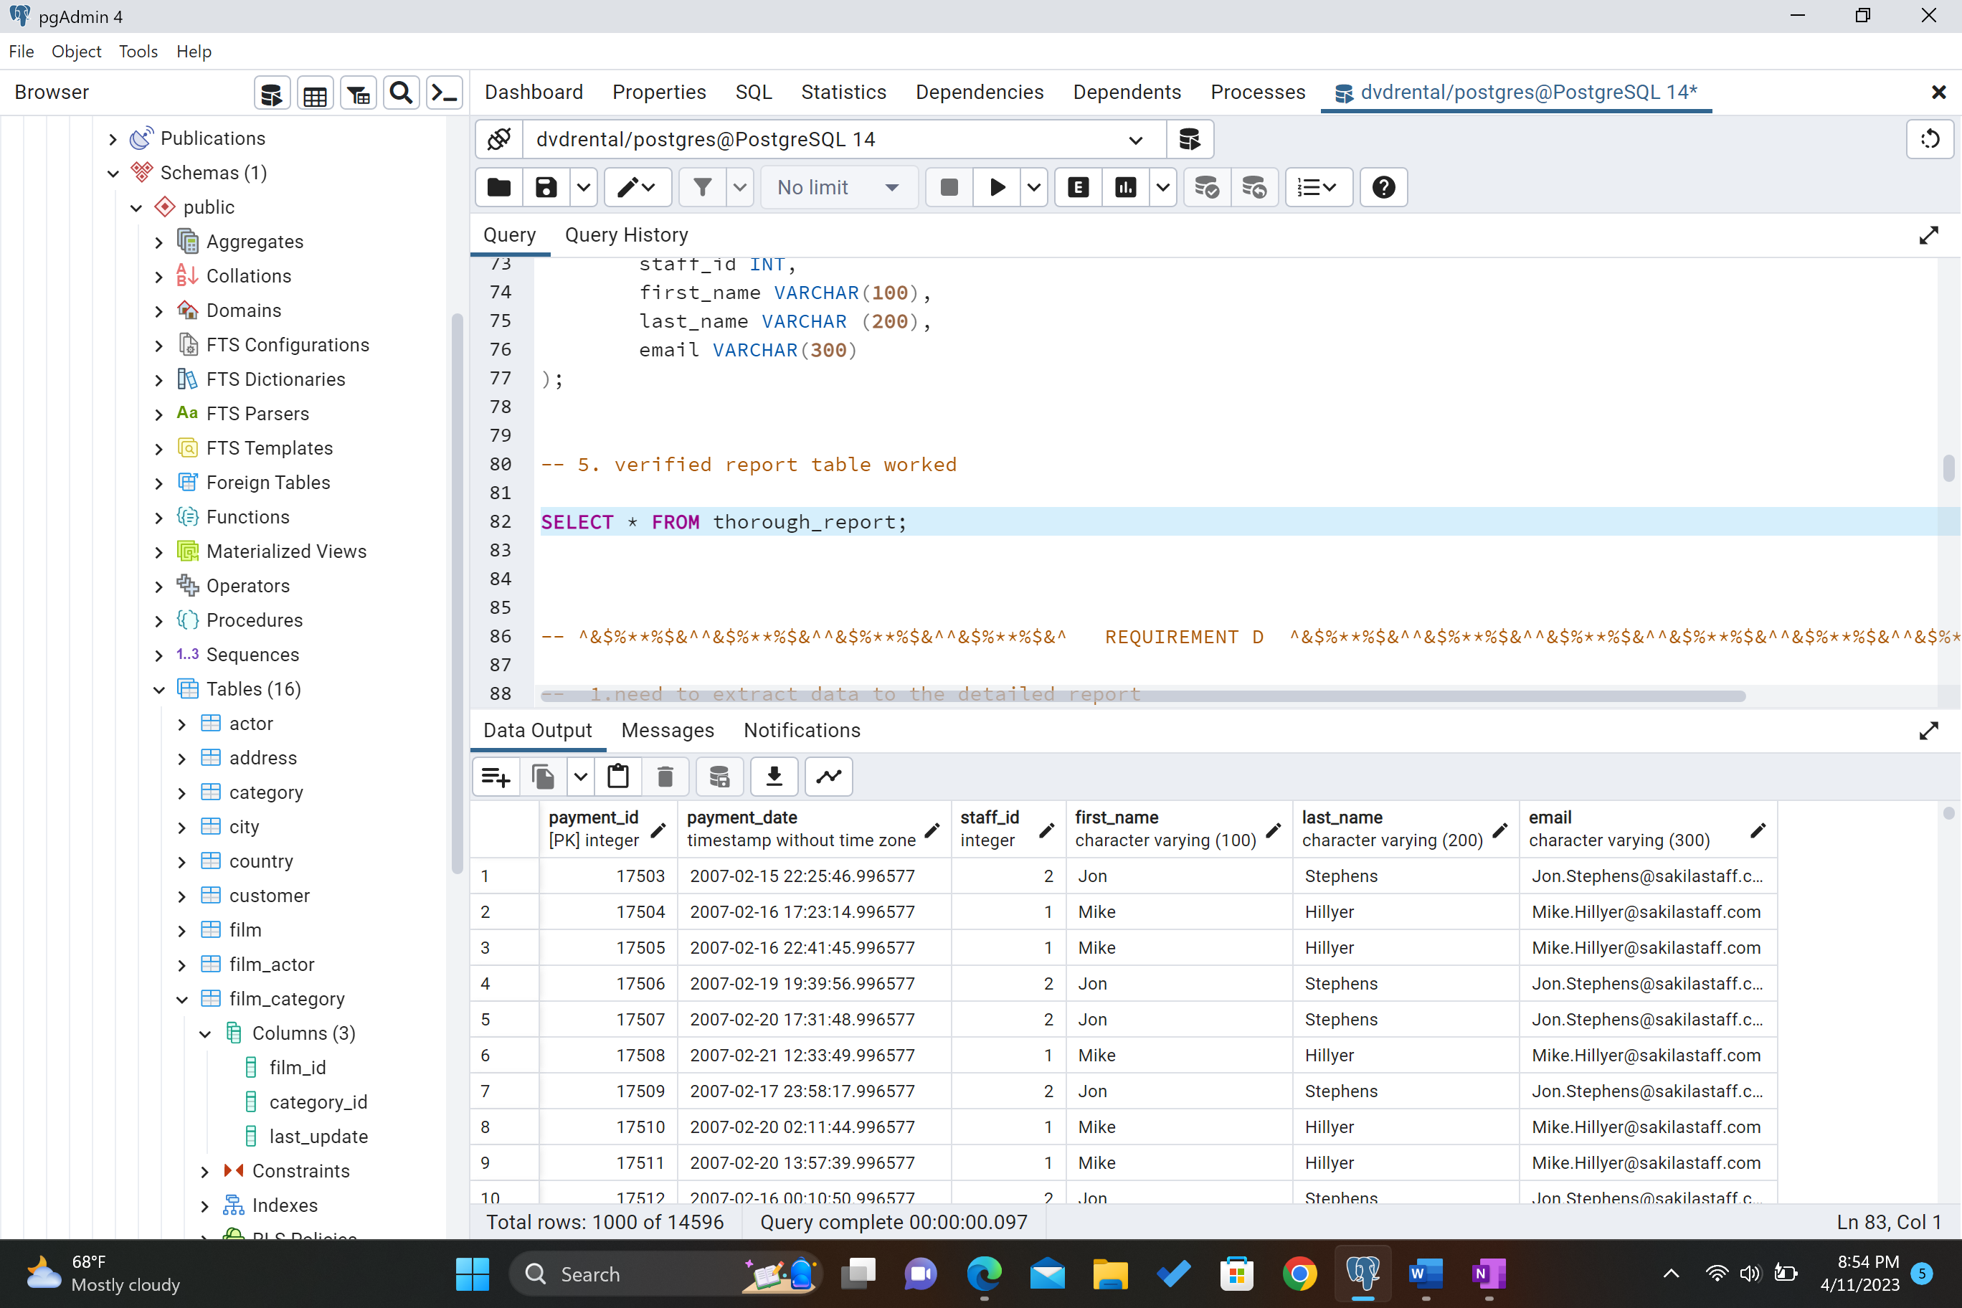

- The Summary report will be able to tell us who are top performing employee is.

- We will be able to use this information to reward our employee.

- This is what the summary table will look like

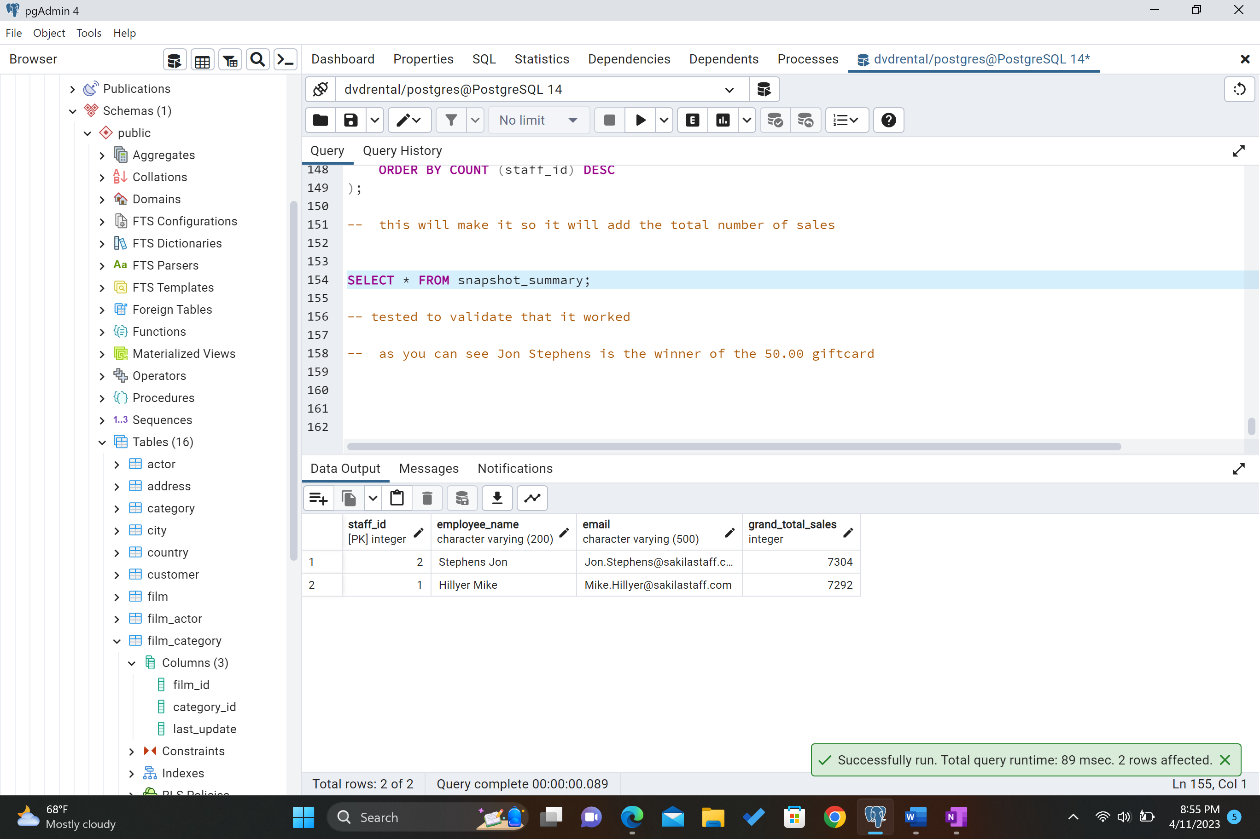

A6. Explain how frequently the report should be refreshed to remain up to date for the stakeholders.

* The detailed report will be run once a month.
* We will use the detailed monthly report to see who is being the best employee.
* The summary report will be run every three months so we can continue to have an ongoing competition.
* We know that the competition of competing against fellow employees will only help our productivity soar.

B. Provide Original SQL Code for the function in A4 that performs the transformation.

Function to concat last name and first name with a space called glue_name_together.

Tested to make sure it was created correctly.

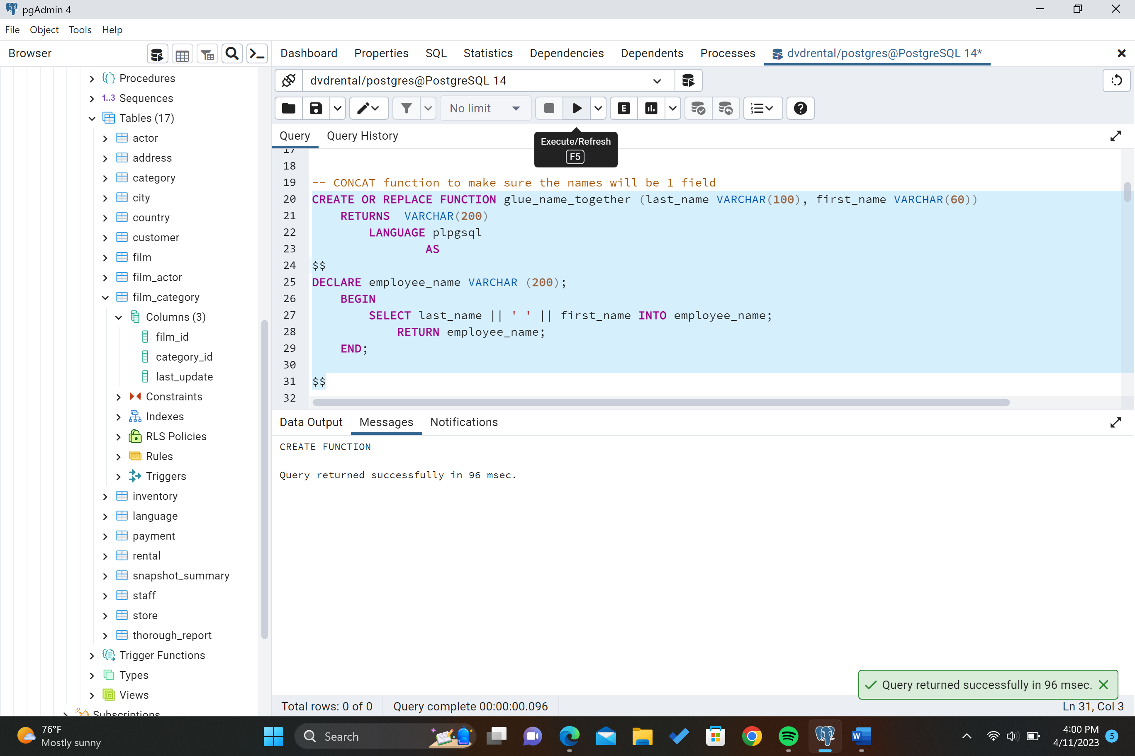

C. Create the detailed and summary tables to hold the reports sections.

Summary table = named snapshot_summary

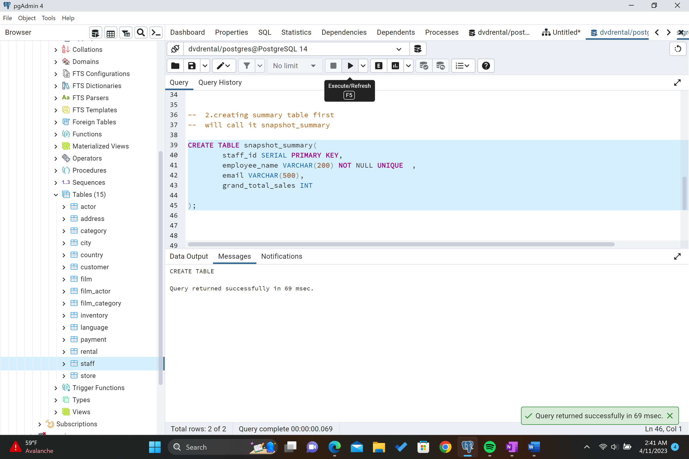

Verified snapshot_summary worked = It worked, it was an empty table.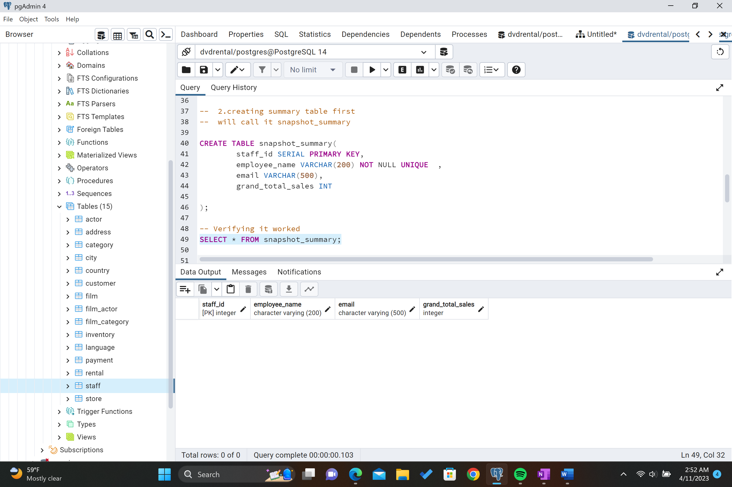

Detailed table = named thorough_report.

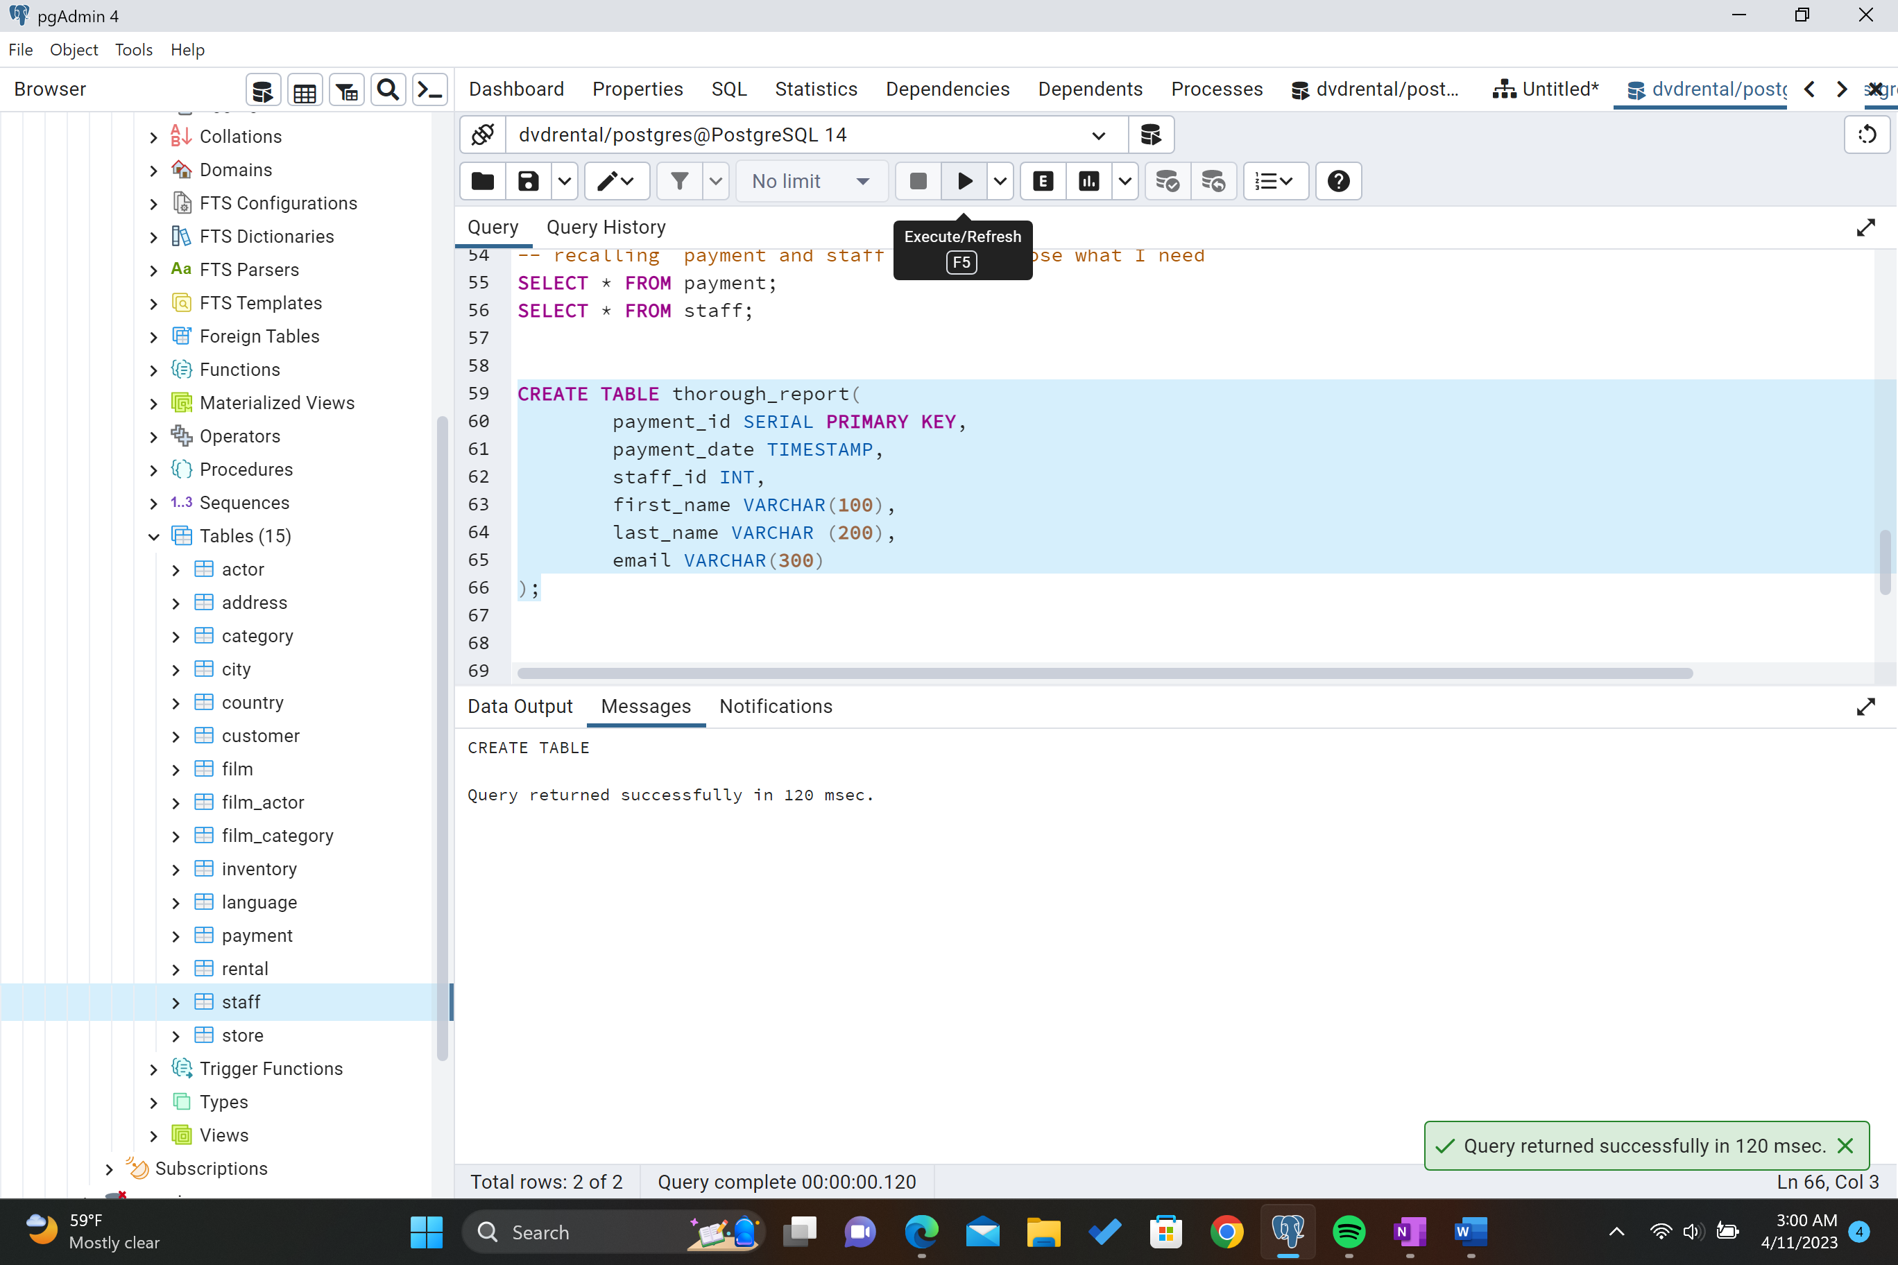

Verified thorough_report worked = It worked, it was an empty table.

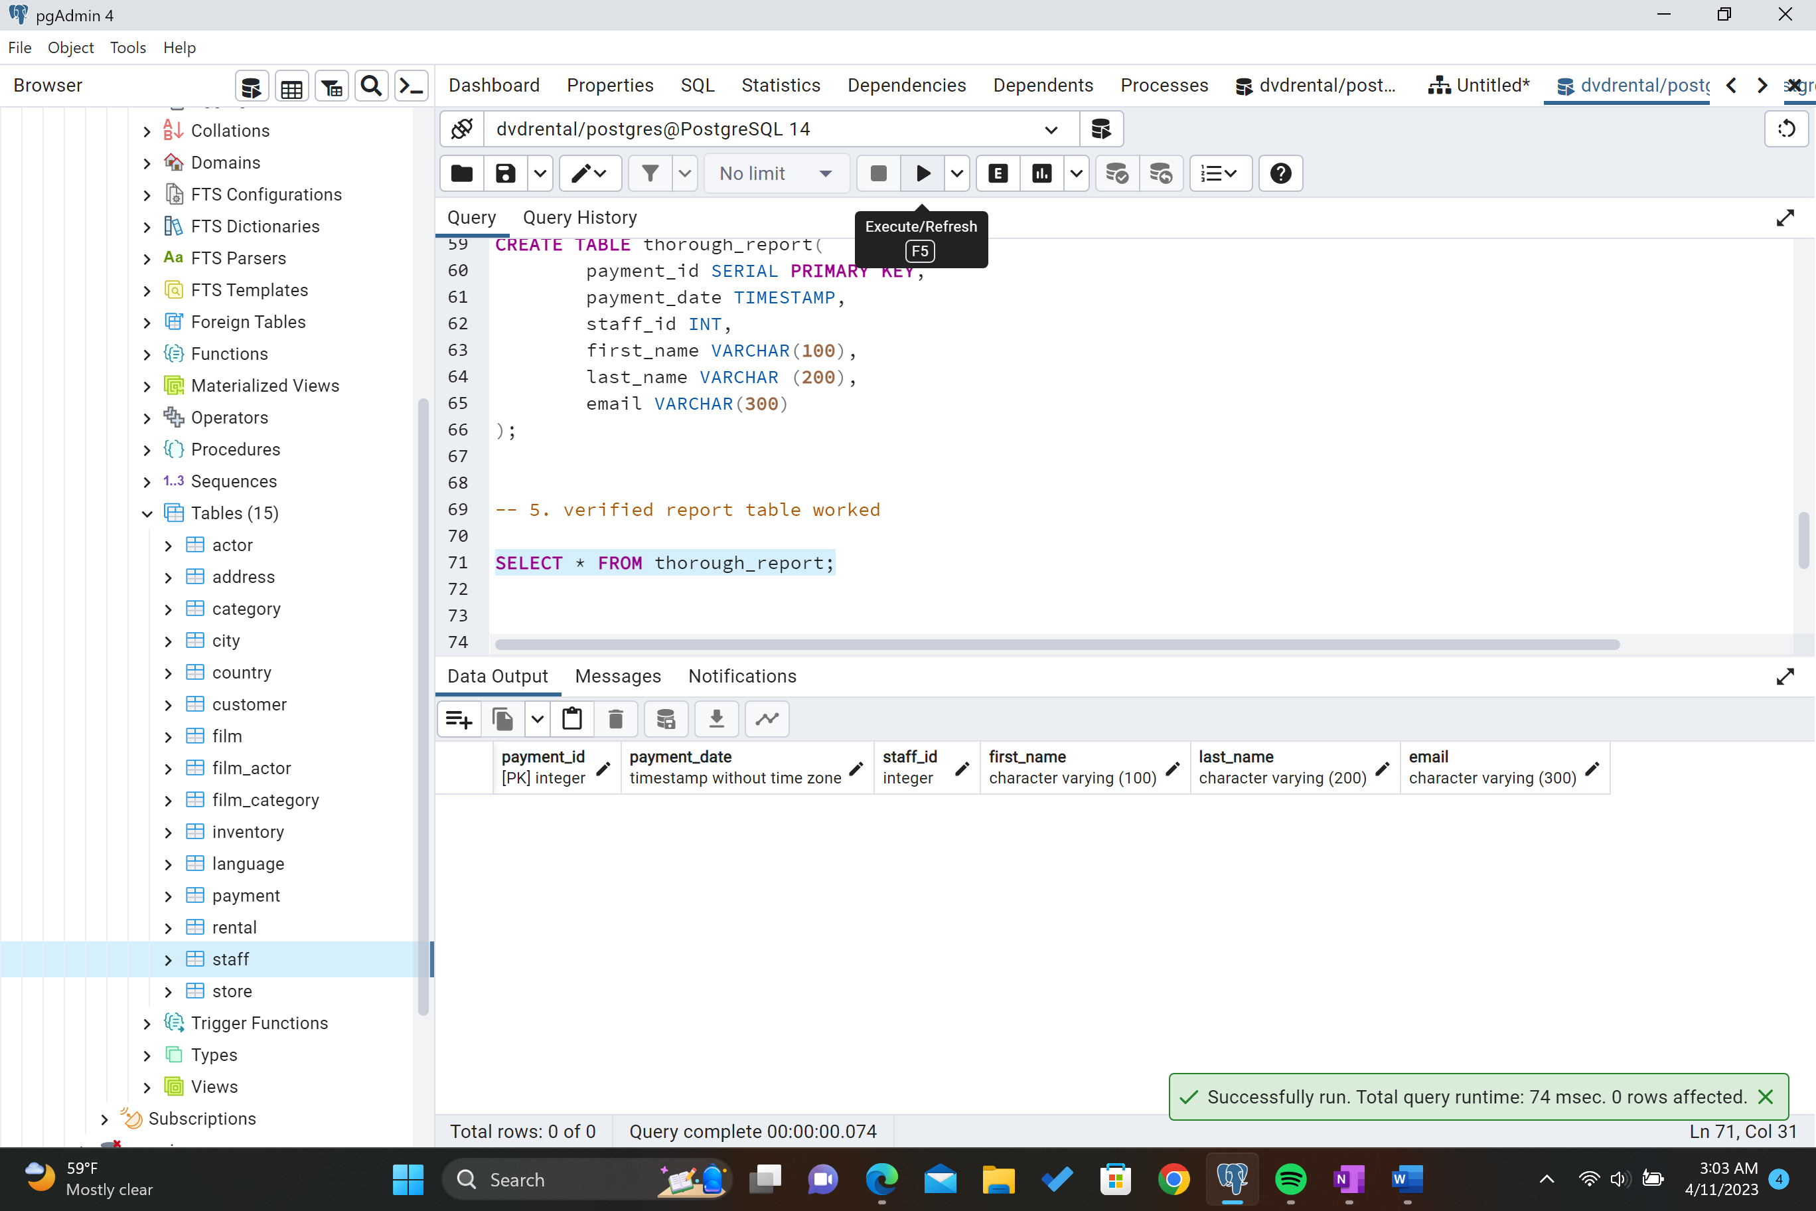

D. Extract in SQL the raw data for the detailed report

Thorough_report screen shot of table successful created.

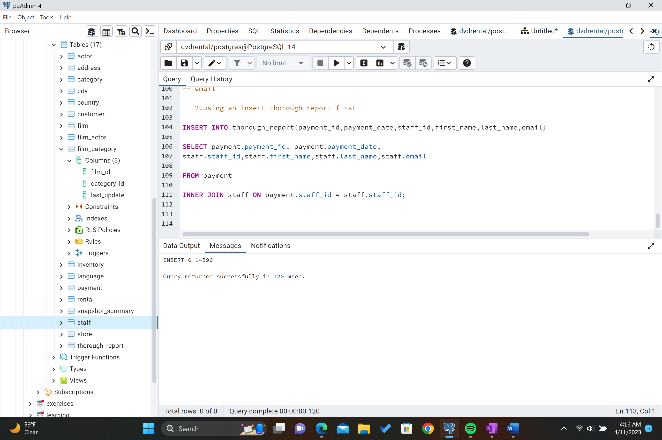

Verified if table was created correctly = It was successfully created. I will now get the results of it counting.

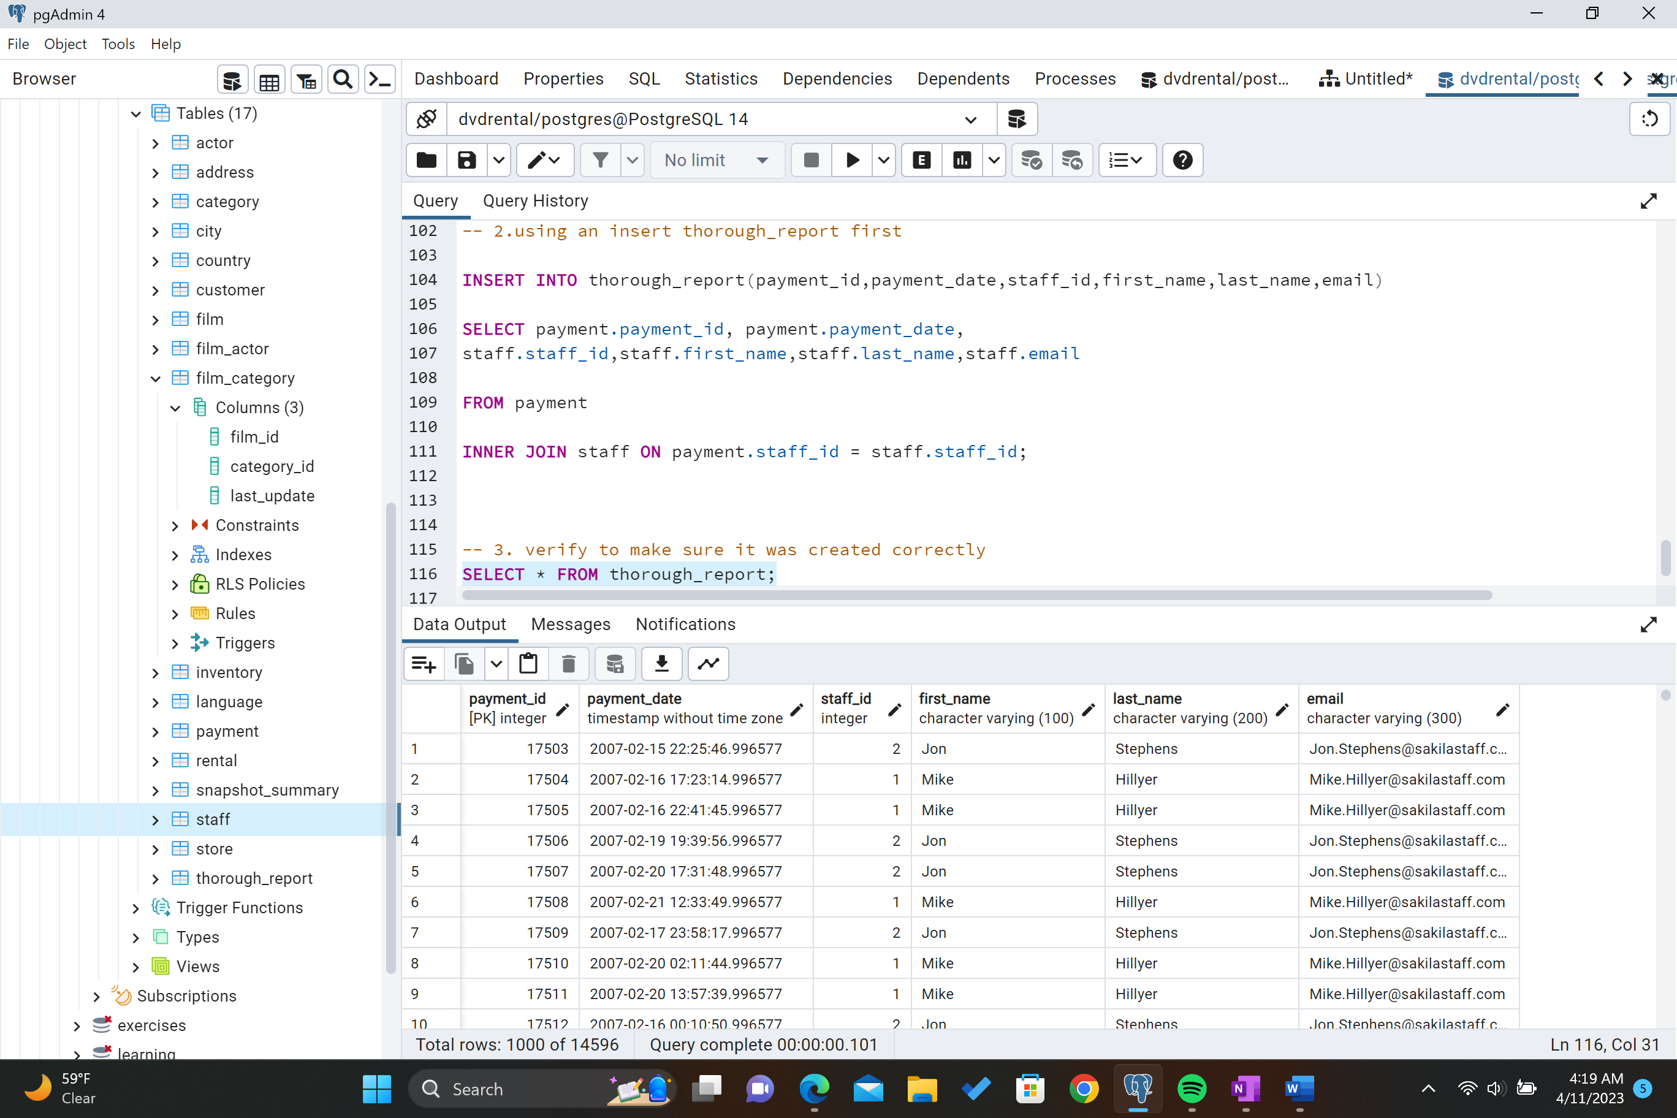

E. Create a trigger on the detailed report that will continually update the summary table as it is added to the detailed table.

Trigger Statement below. It said it ran successfully.

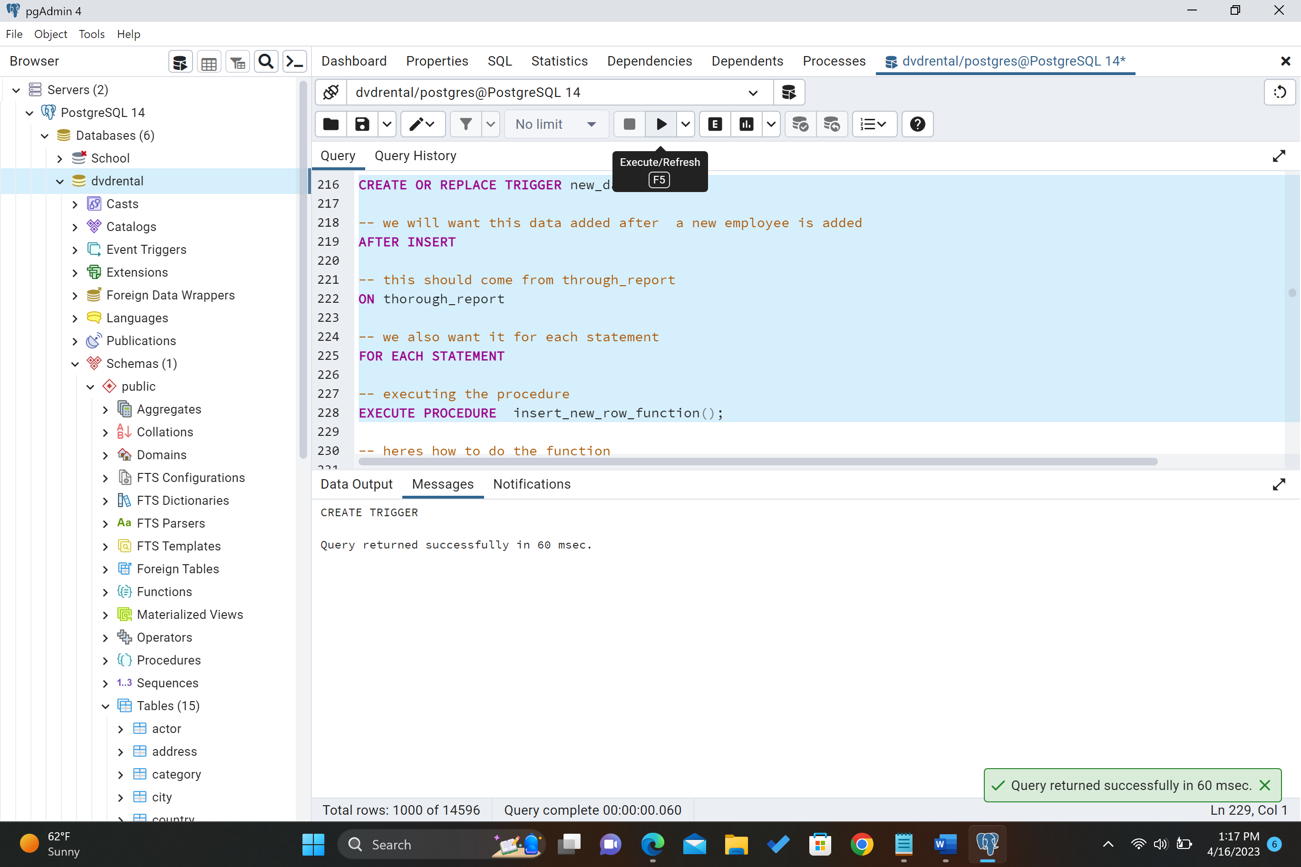

Trigger Function below (part1/2).

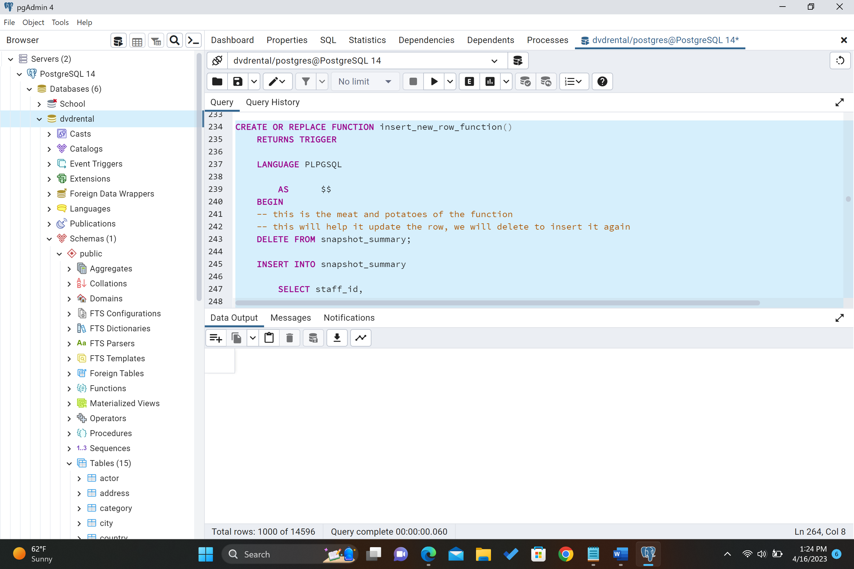

Trigger Function Below(part2/2).

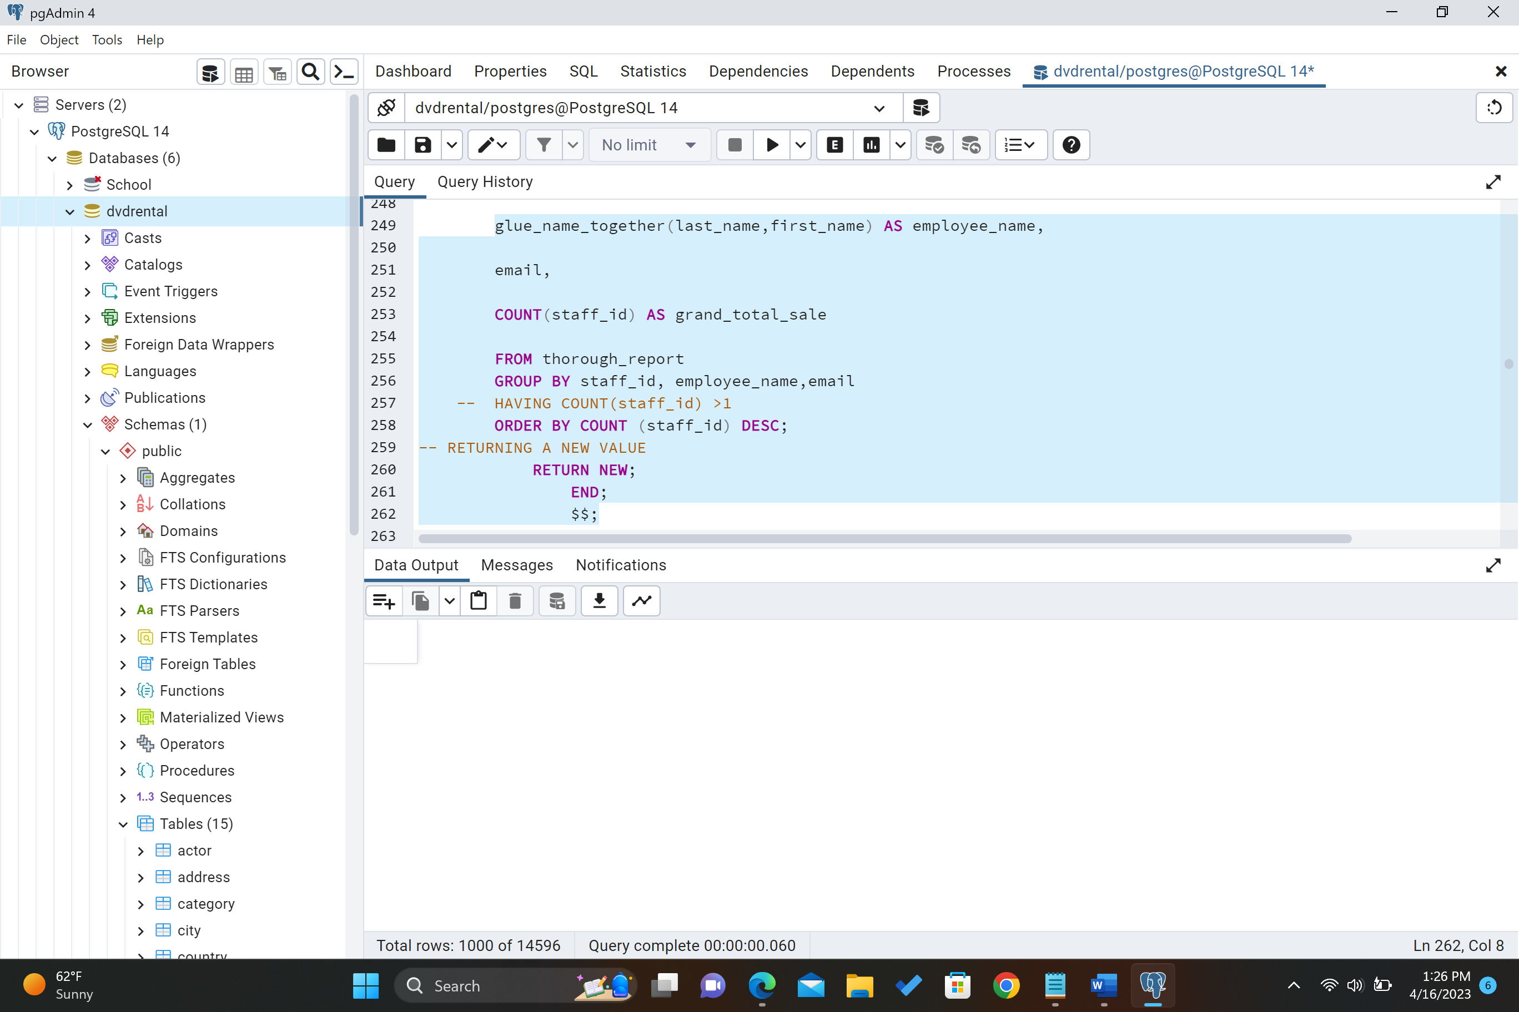

Result of Trigger running successfully below.

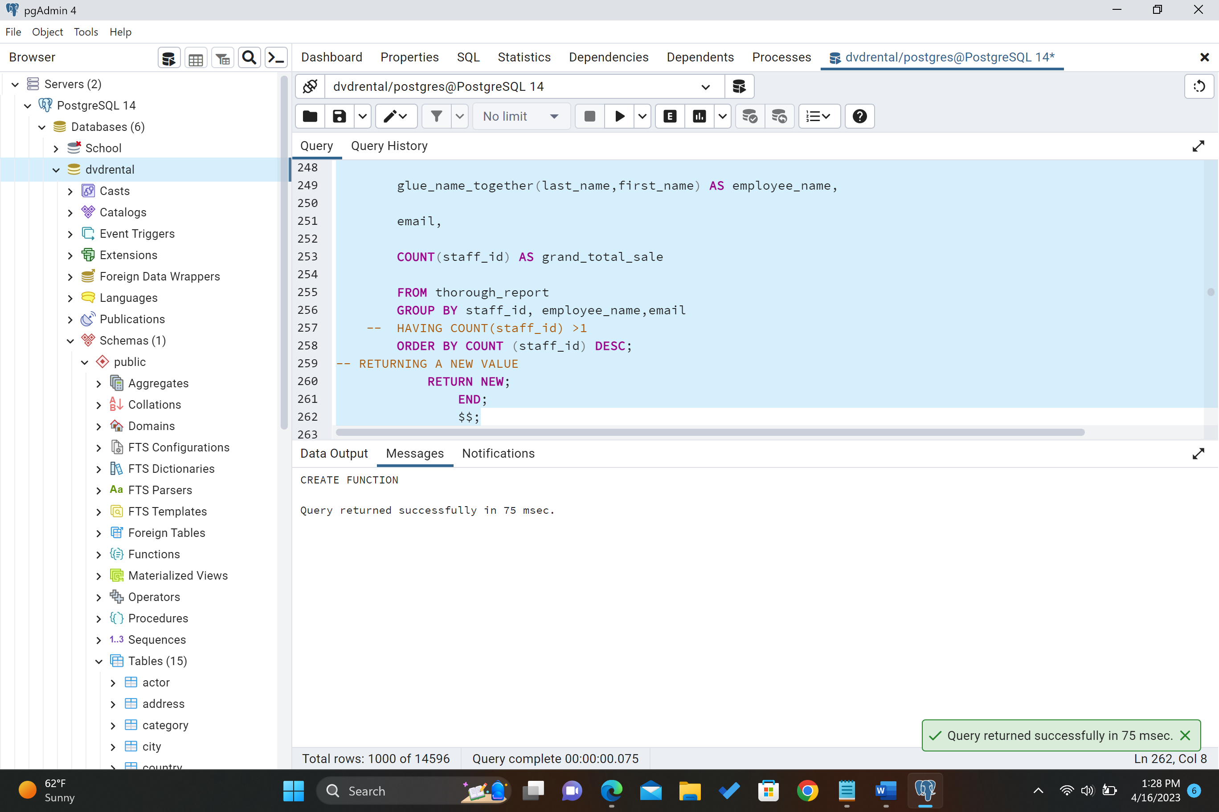

Testing the trigger below. Updated thorough_report with the total number increased by 1.

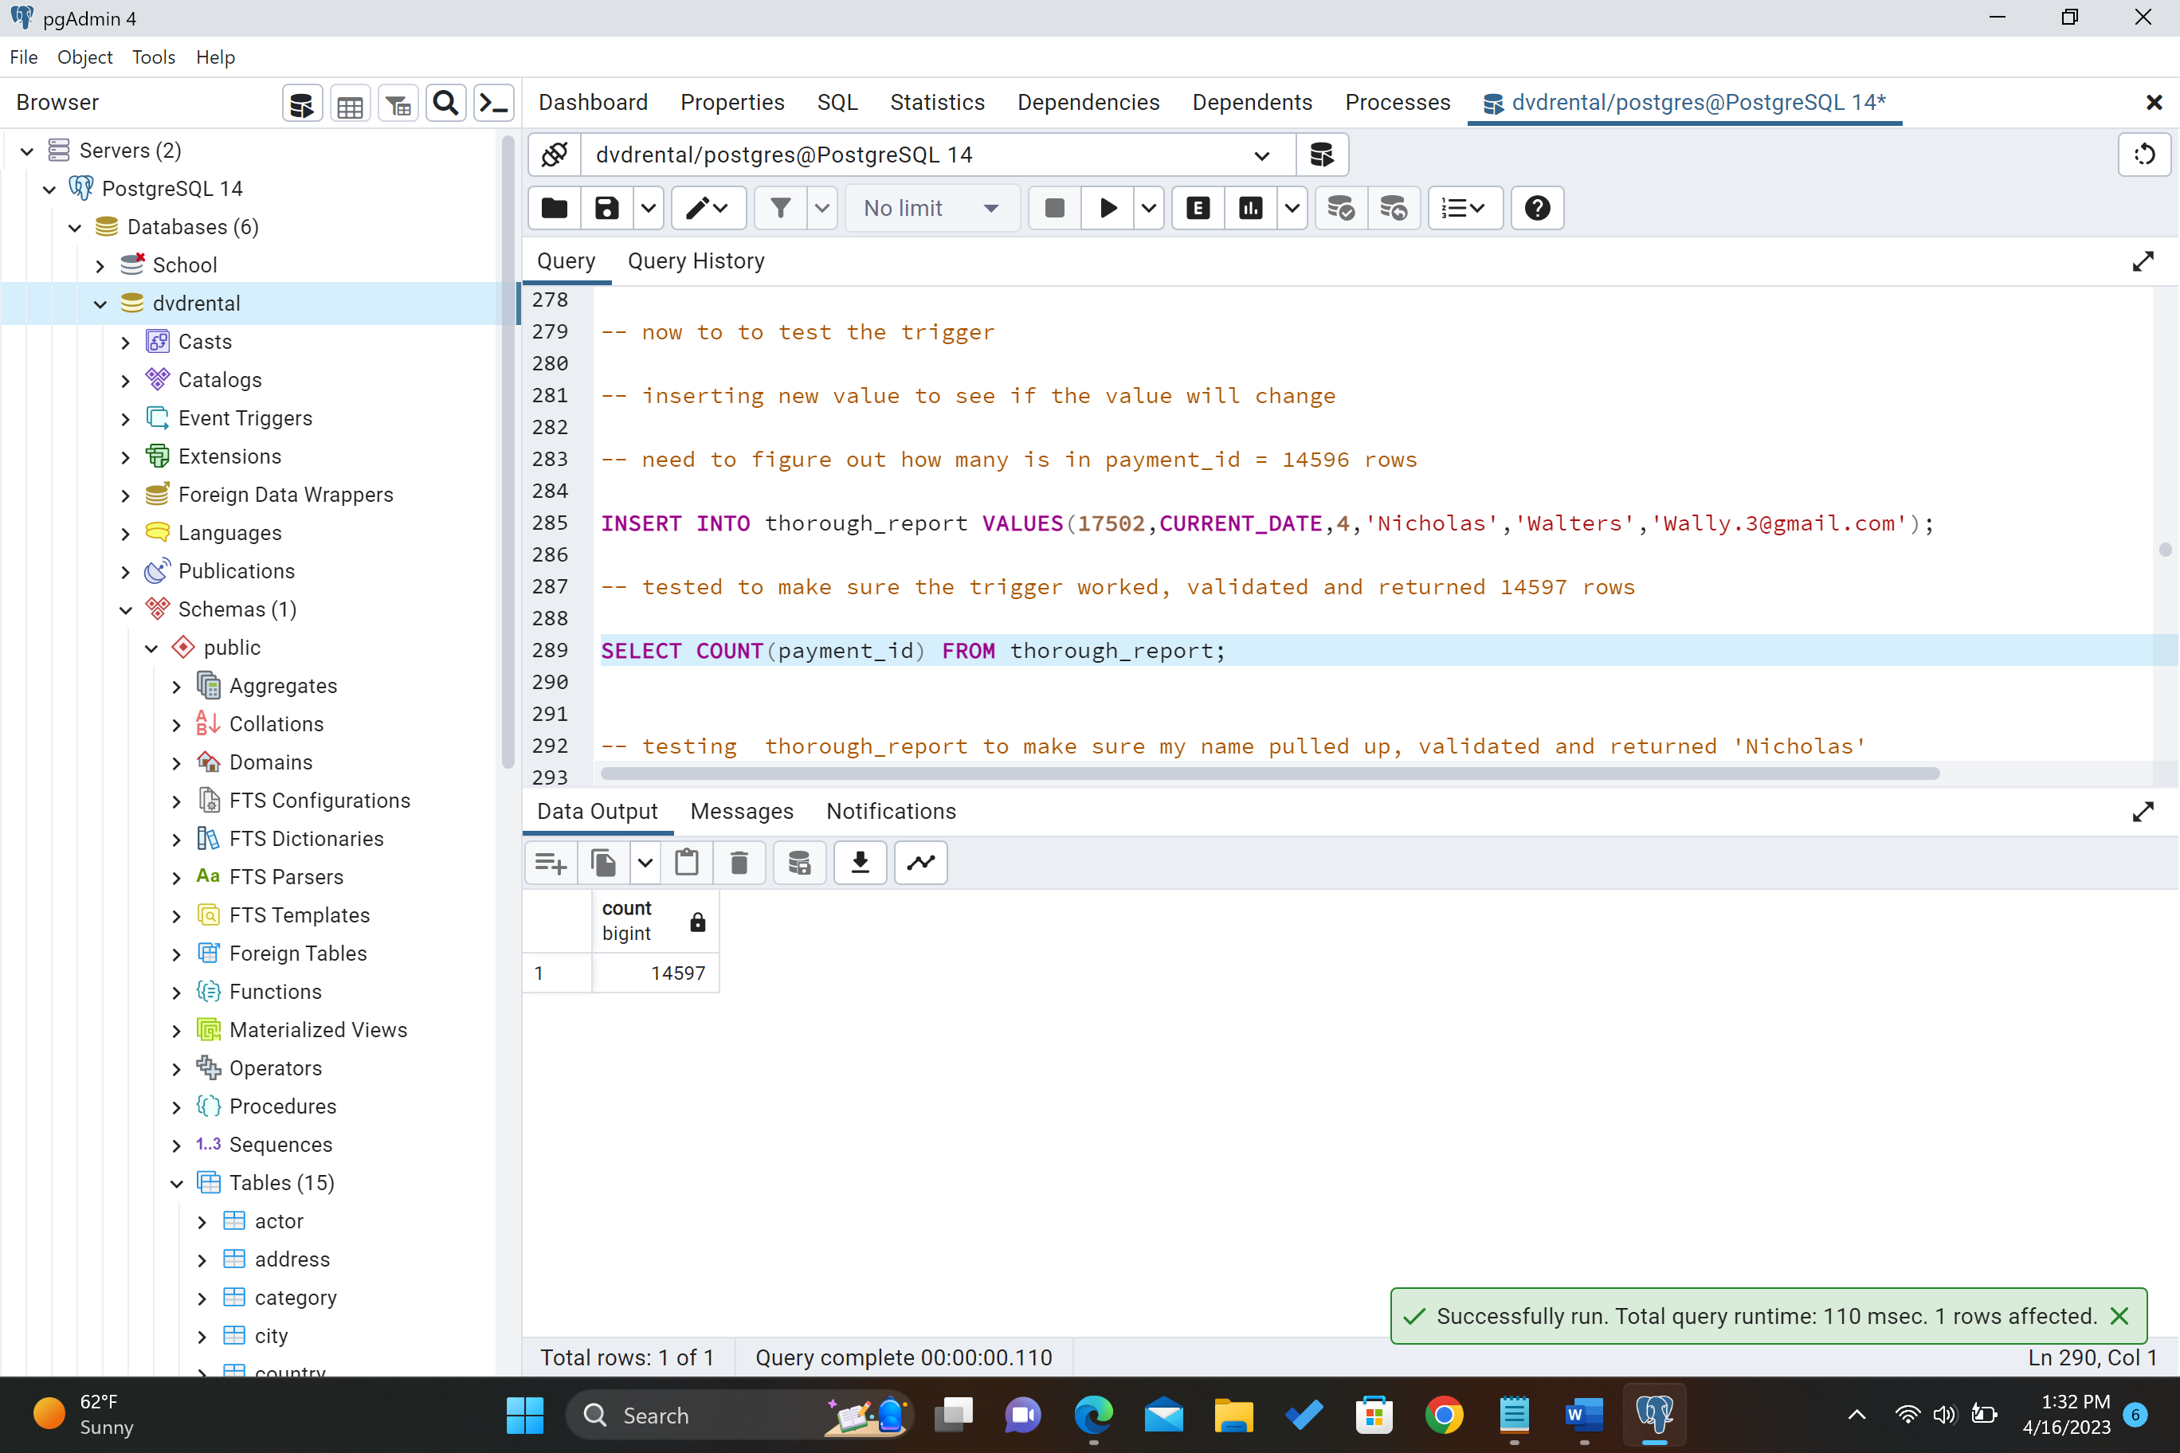

Updated through_report with my name showing up in the query.

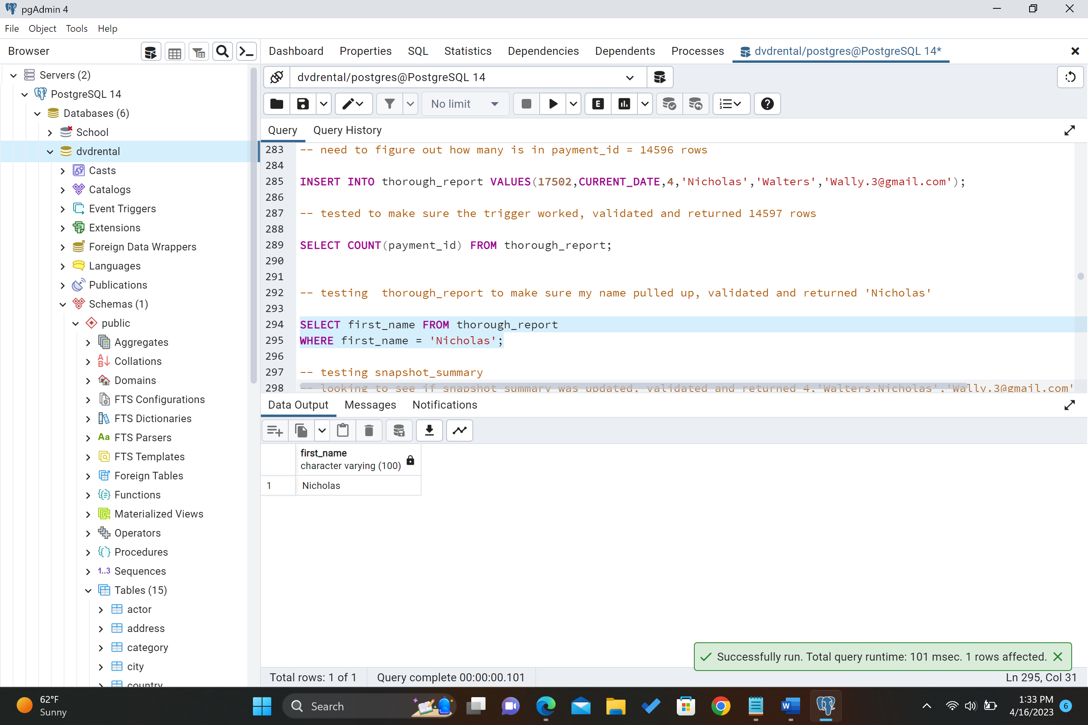

Updated snapshot_summary test to make sure that it pulls up the information from thorough_report below.

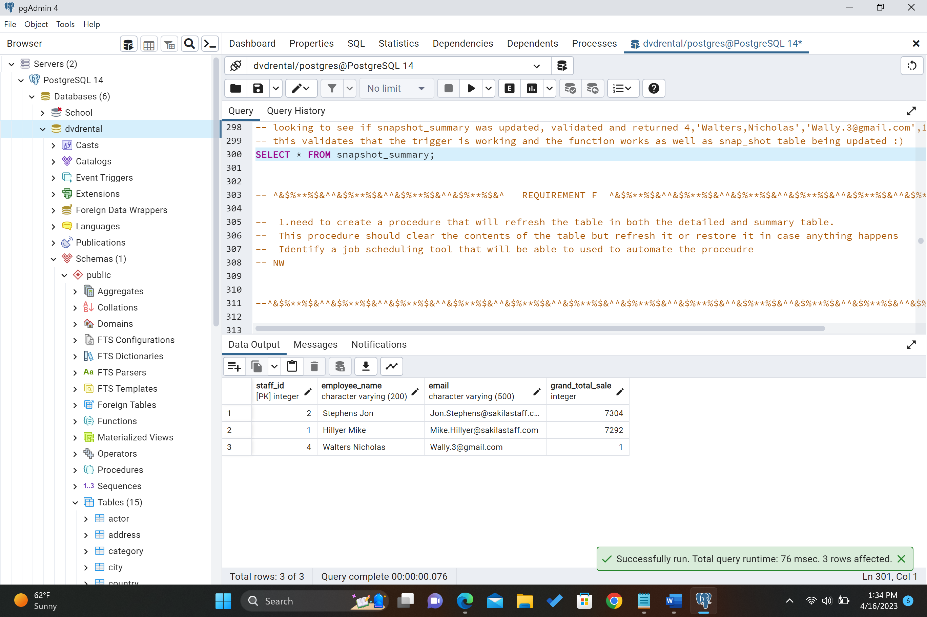

F. Create a procedure that can be used in the detailed and summary table. It needs to clear the contents of both tables and perform the extraction from part D.

Procedure #1 below (part 1/4), called delete_table_fix. This will be used if someone accidentally deletes the table. This will restore both tables after it is called.

I also created another procedure to refresh the tables specific data is deleted on accident and I called it revive. The screen shots of revive is after the delete_table_fix procedure.

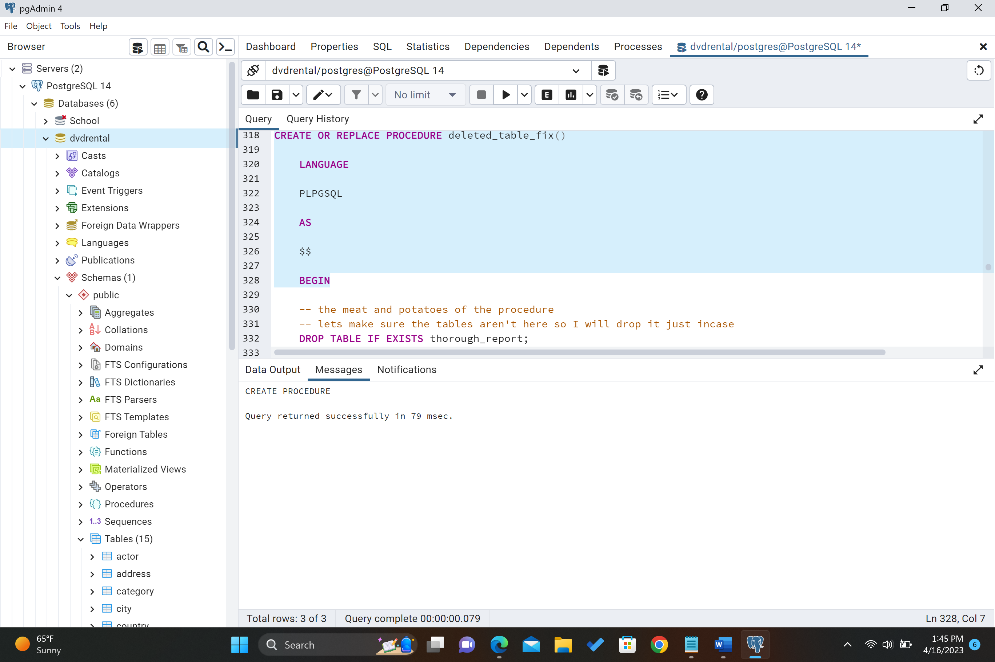

Below is the remaining code for deleted_table_fix procedure #1(part 2/4).

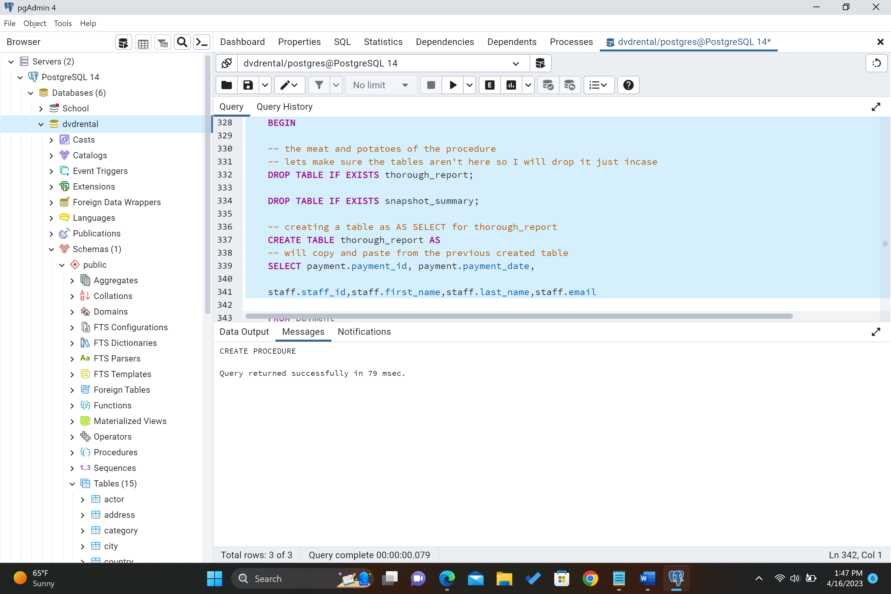

Below (part 3/4)

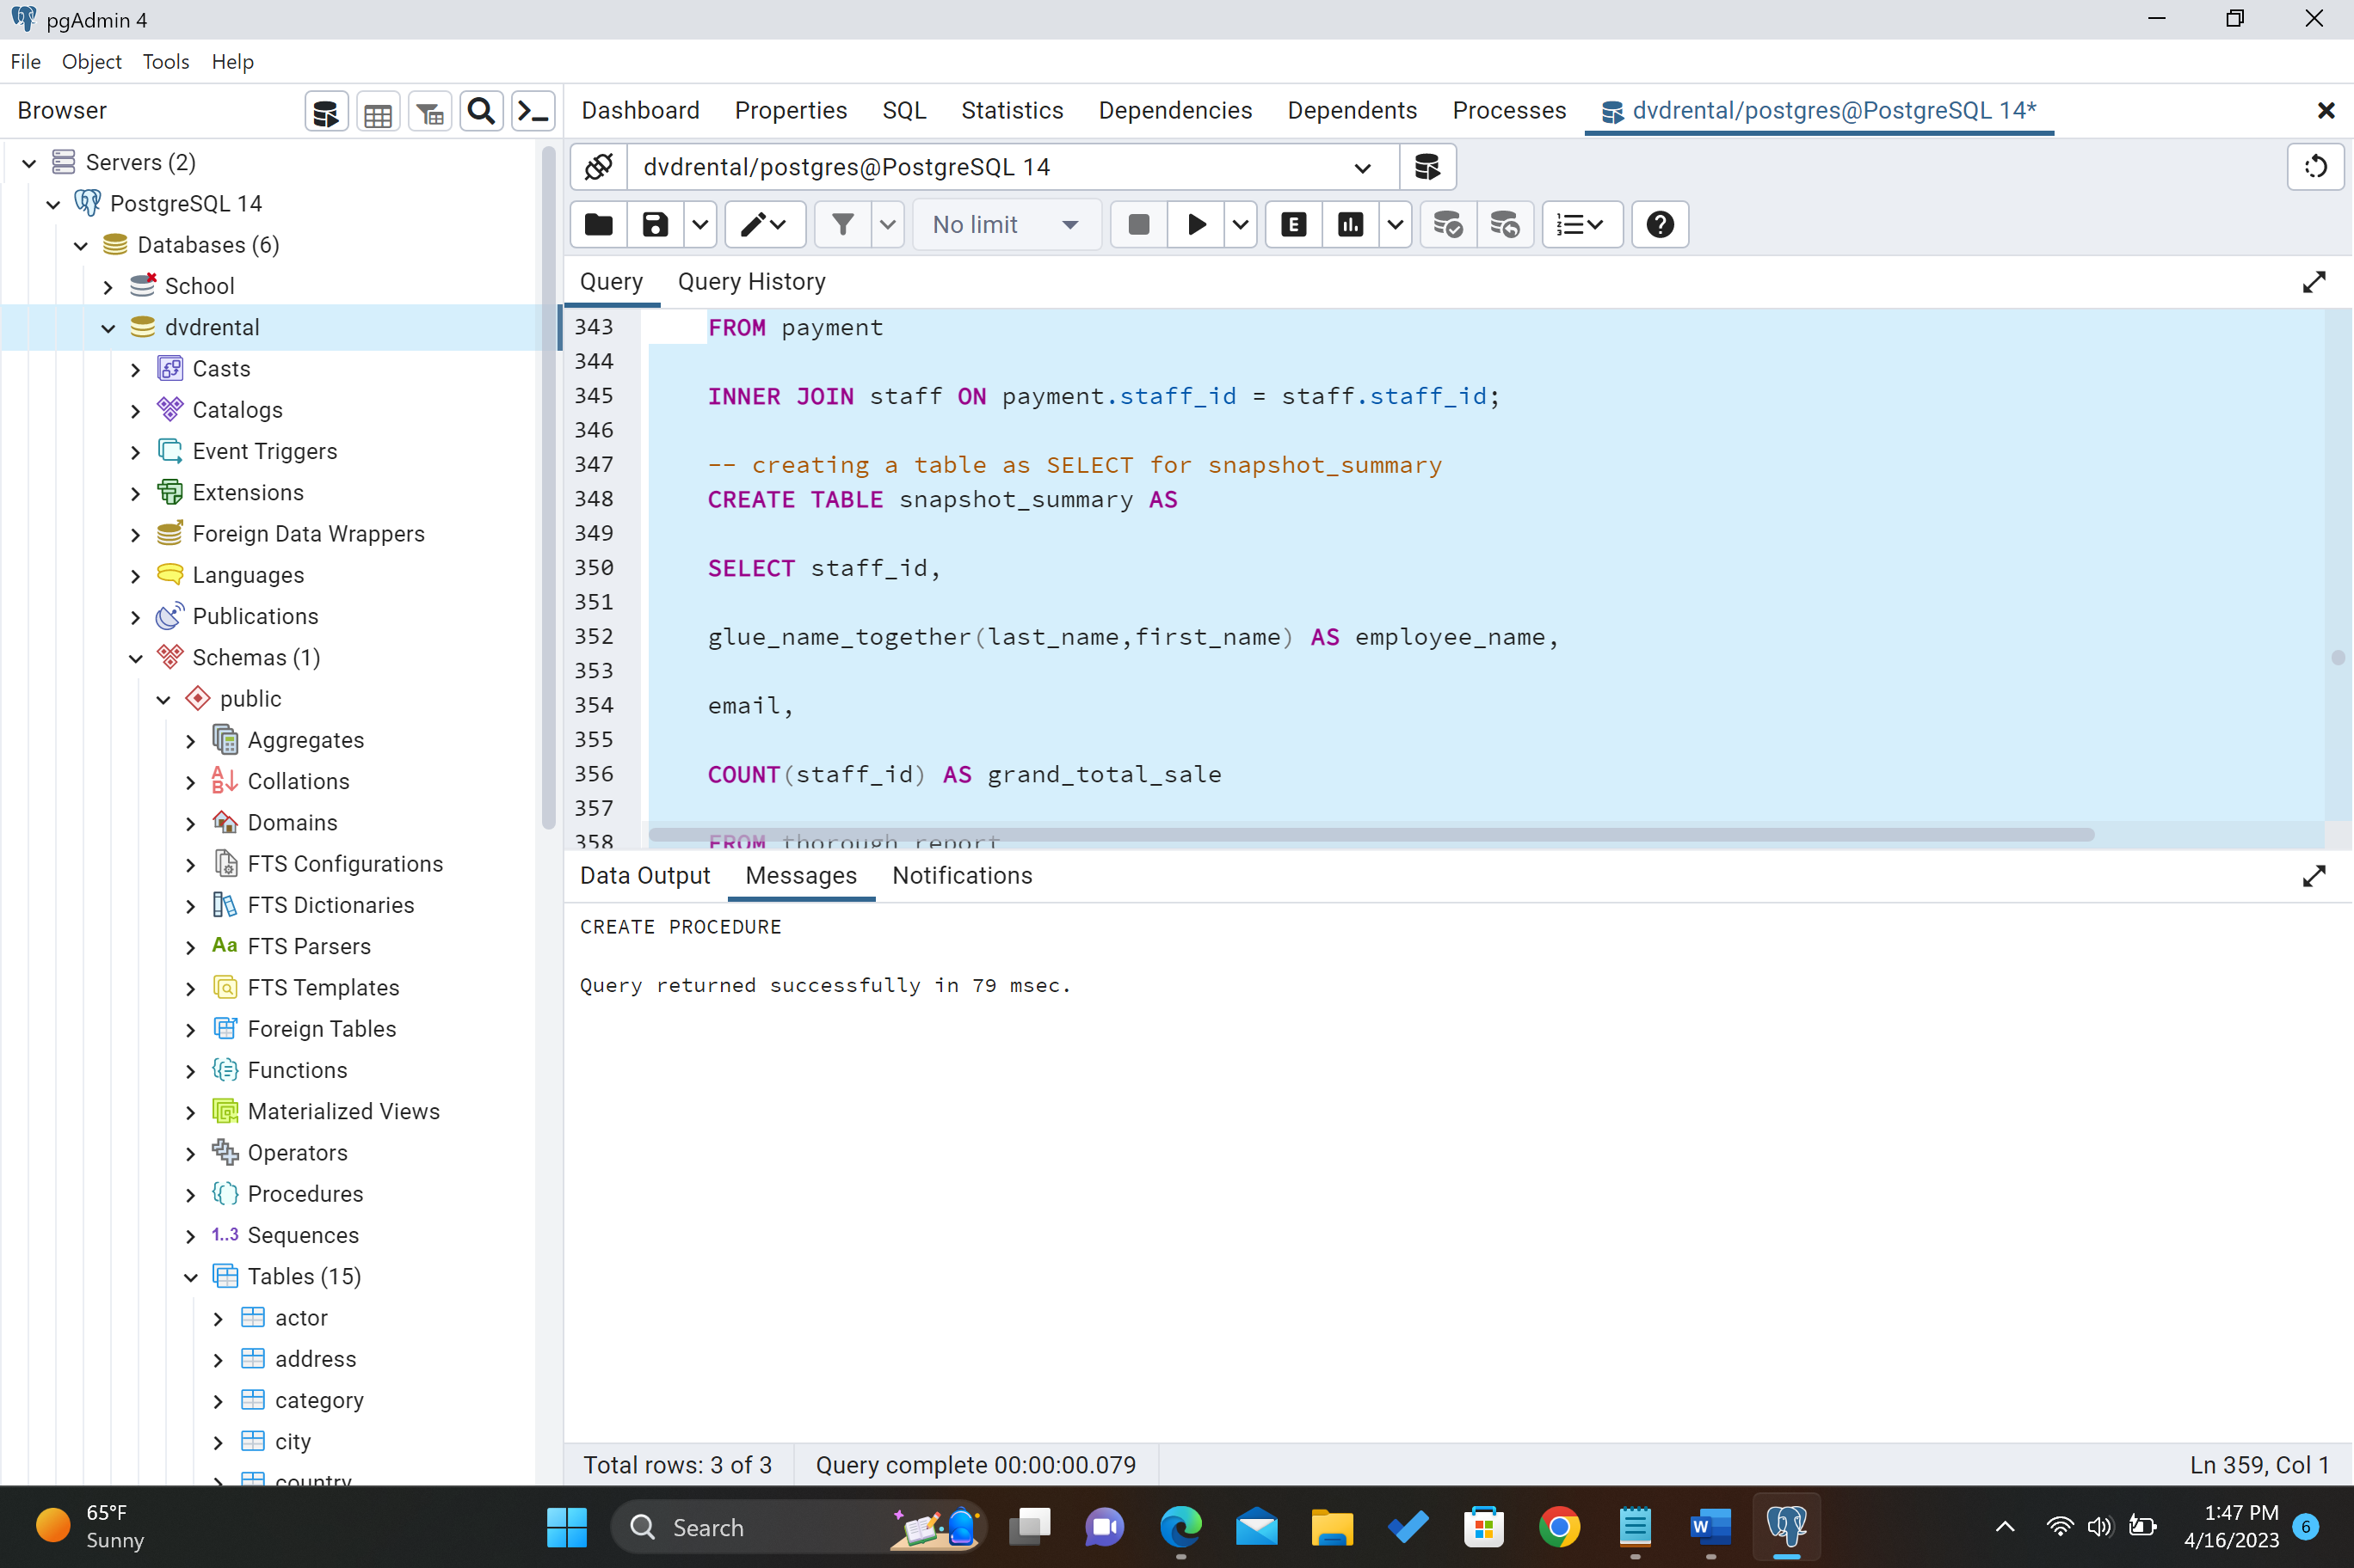

Below (part 4/4)

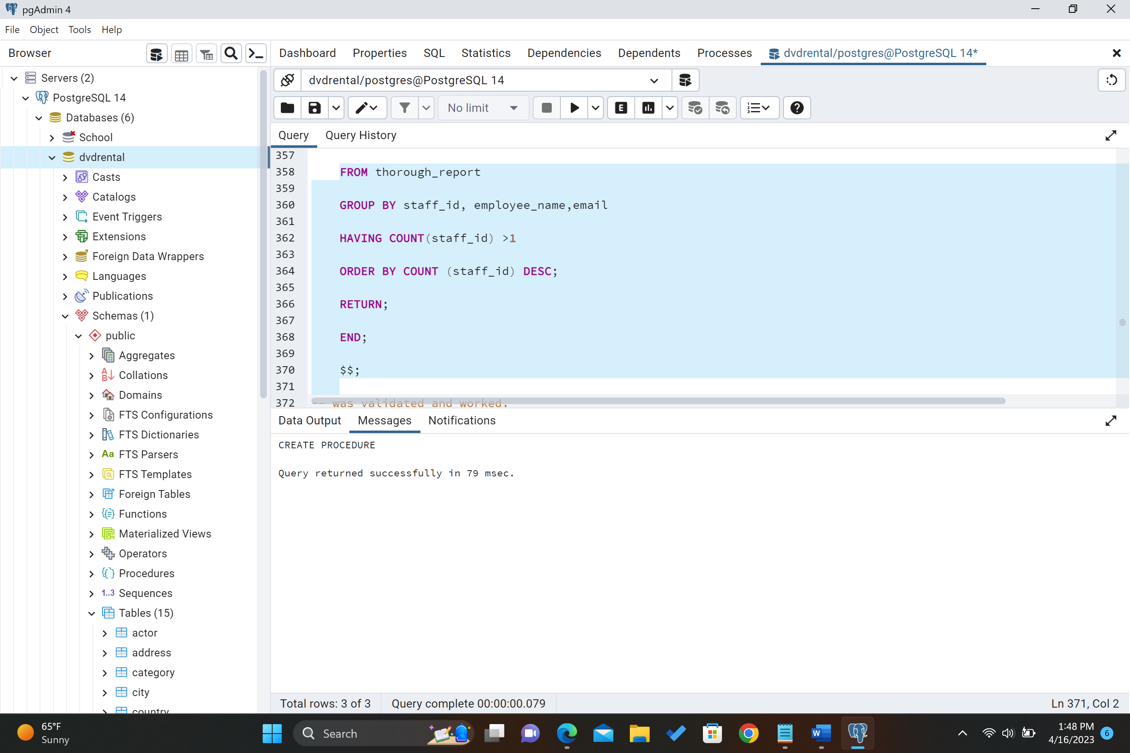

Procedure # 1 deleted_table_fix created successfully below.

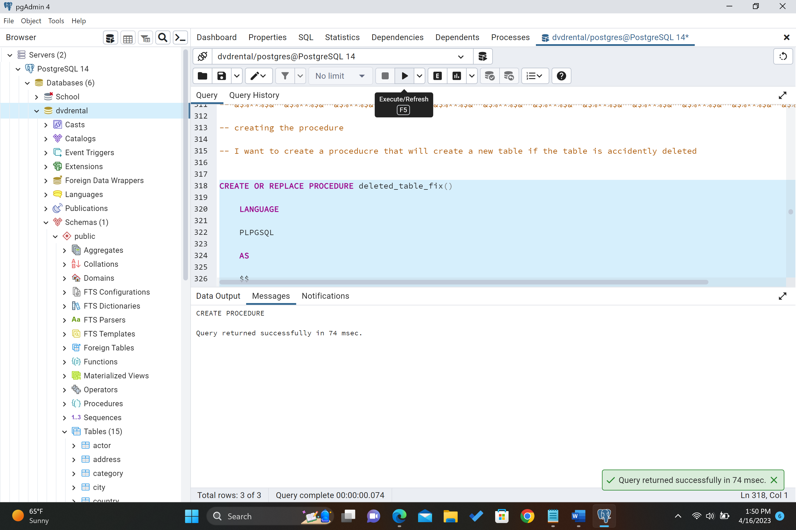

Testing Procedure code #1 deleted_table_fix below.

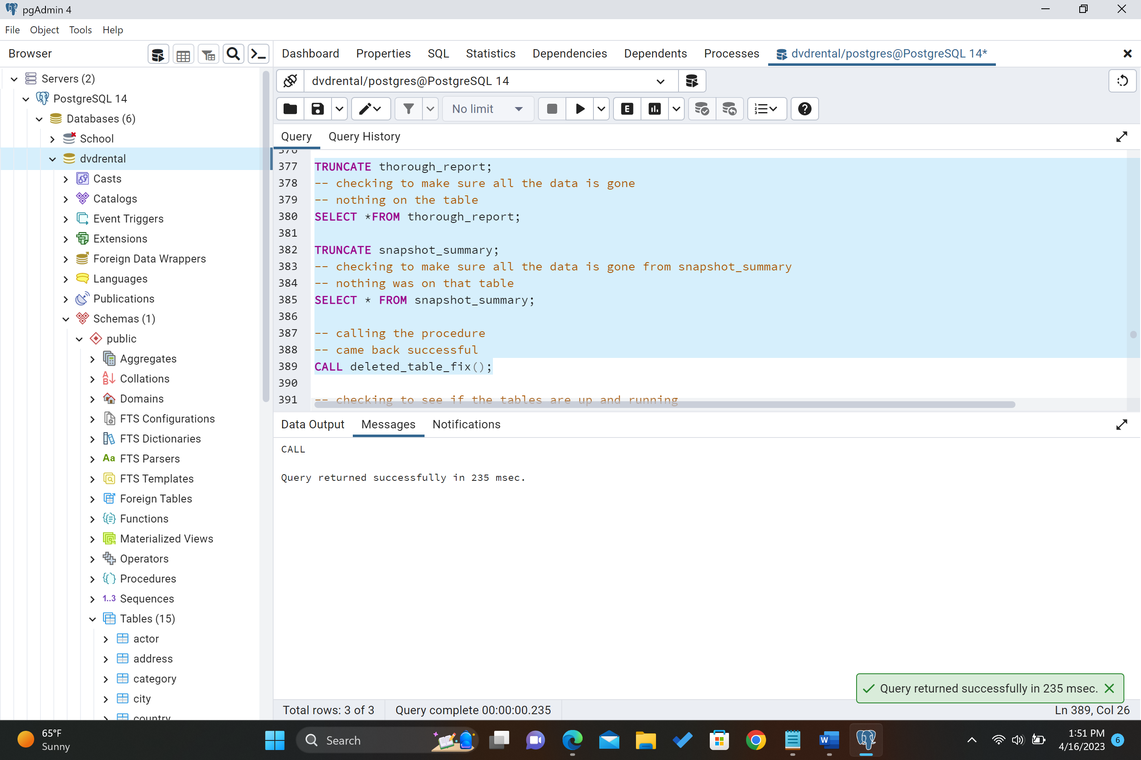

Results of the through_report after testing the procedure below.

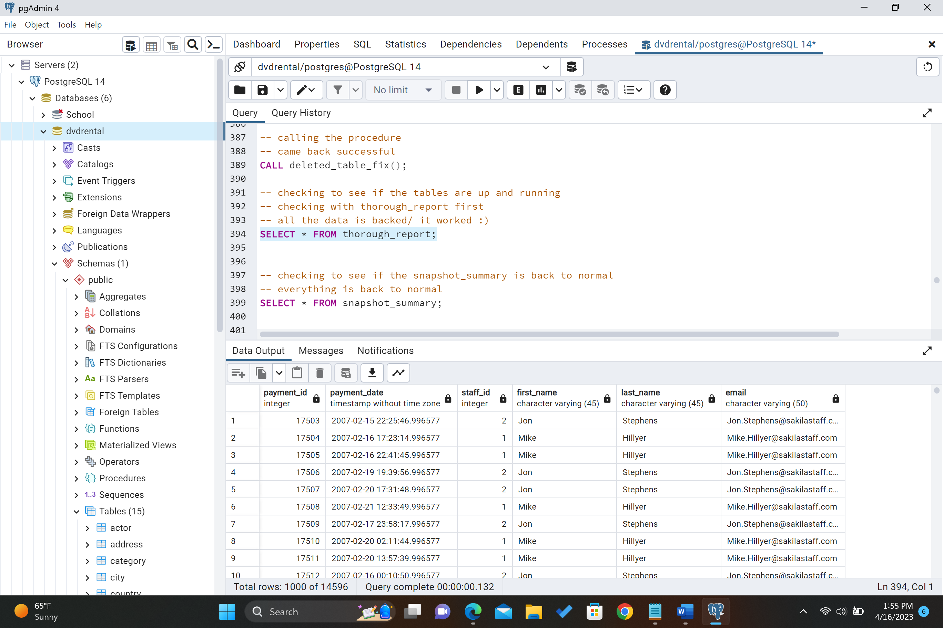

Results of snapshot_summary after testing deleted_table_fix procedure below.

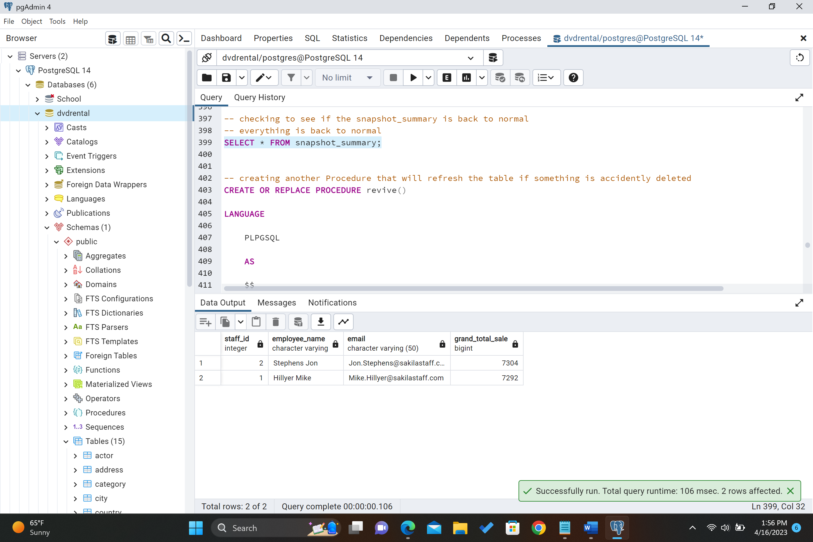

Procedure #2 revive part (1/4) below.

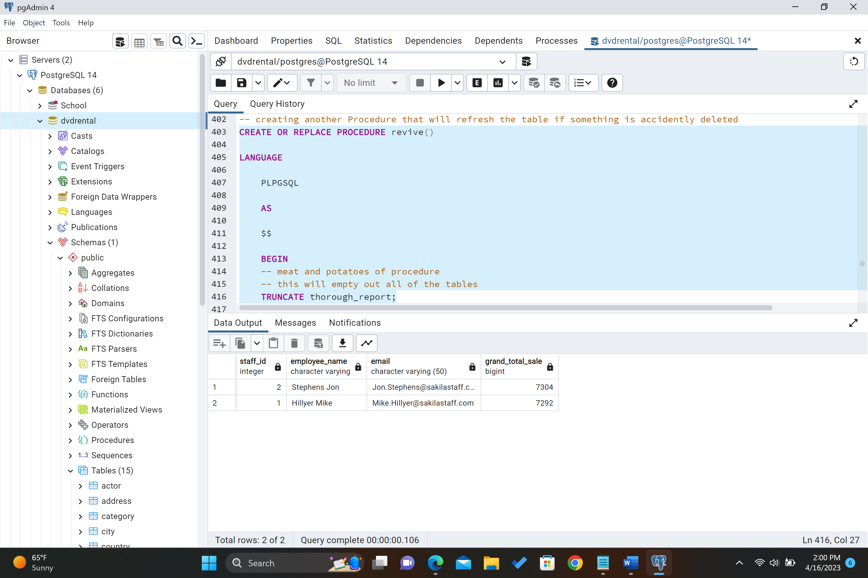

Below part (2/4)

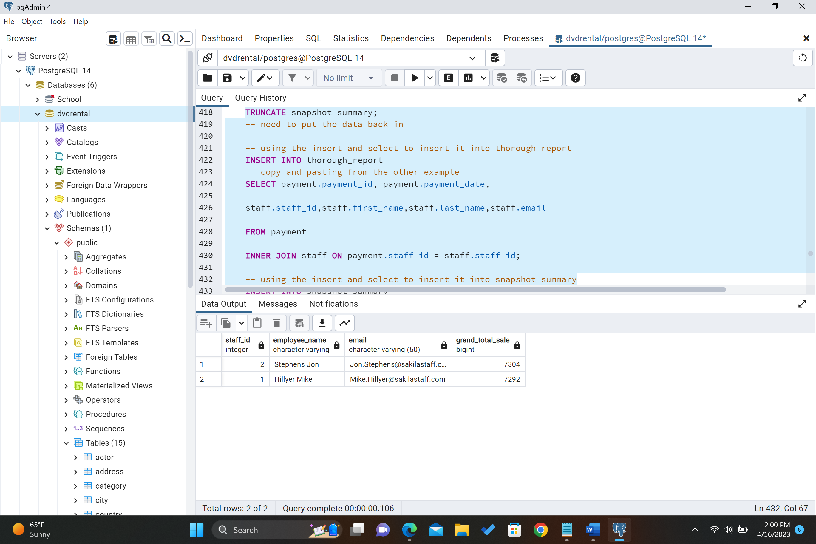

Below part (3/4)

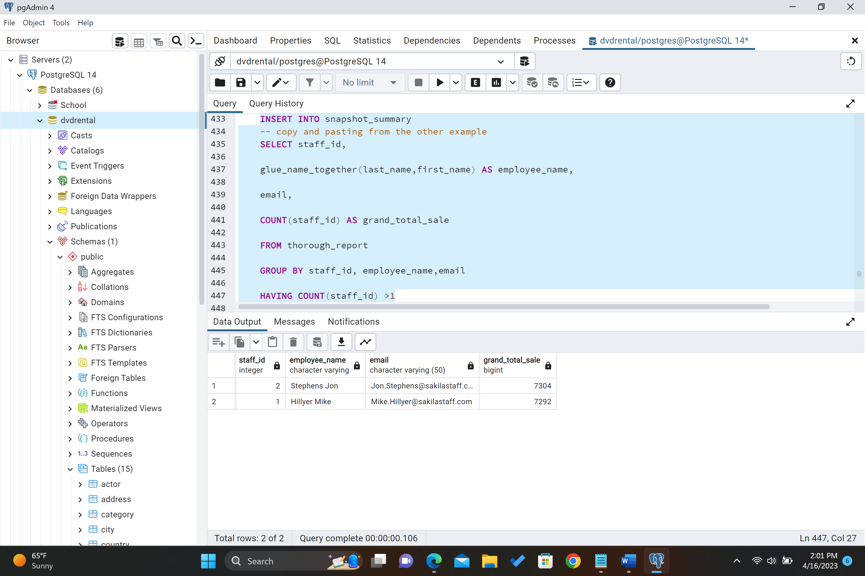

Below part (4/4)

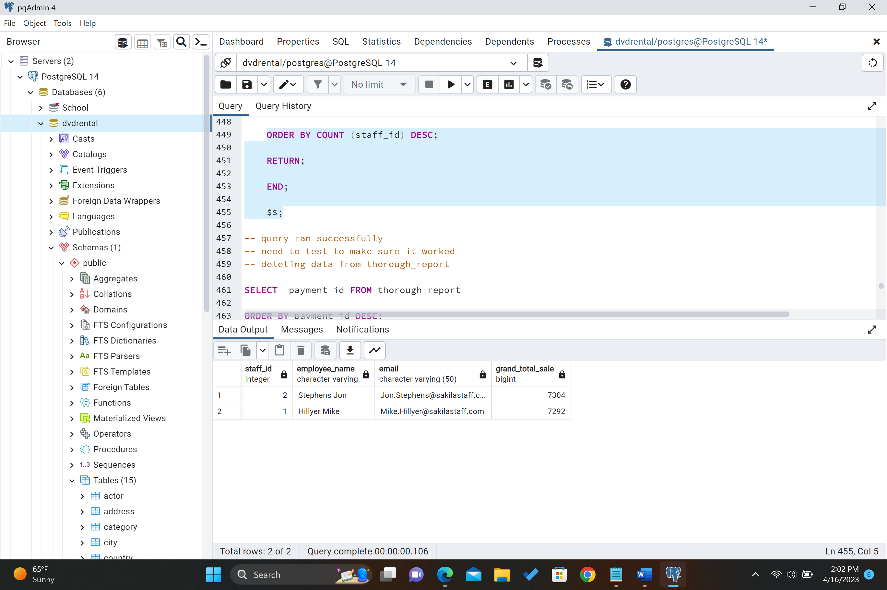

Verifying that revive was created successfully below.

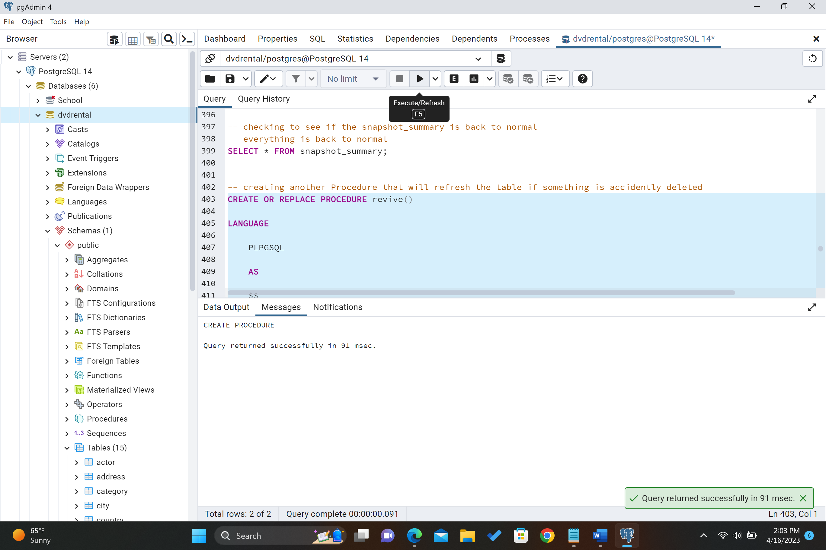

Testing Procedure # 2 revive worked. Before running the procedure we have 14596 number of rows.

Below is the code to test revive procedure. I will delete a bunch of payment of ids.

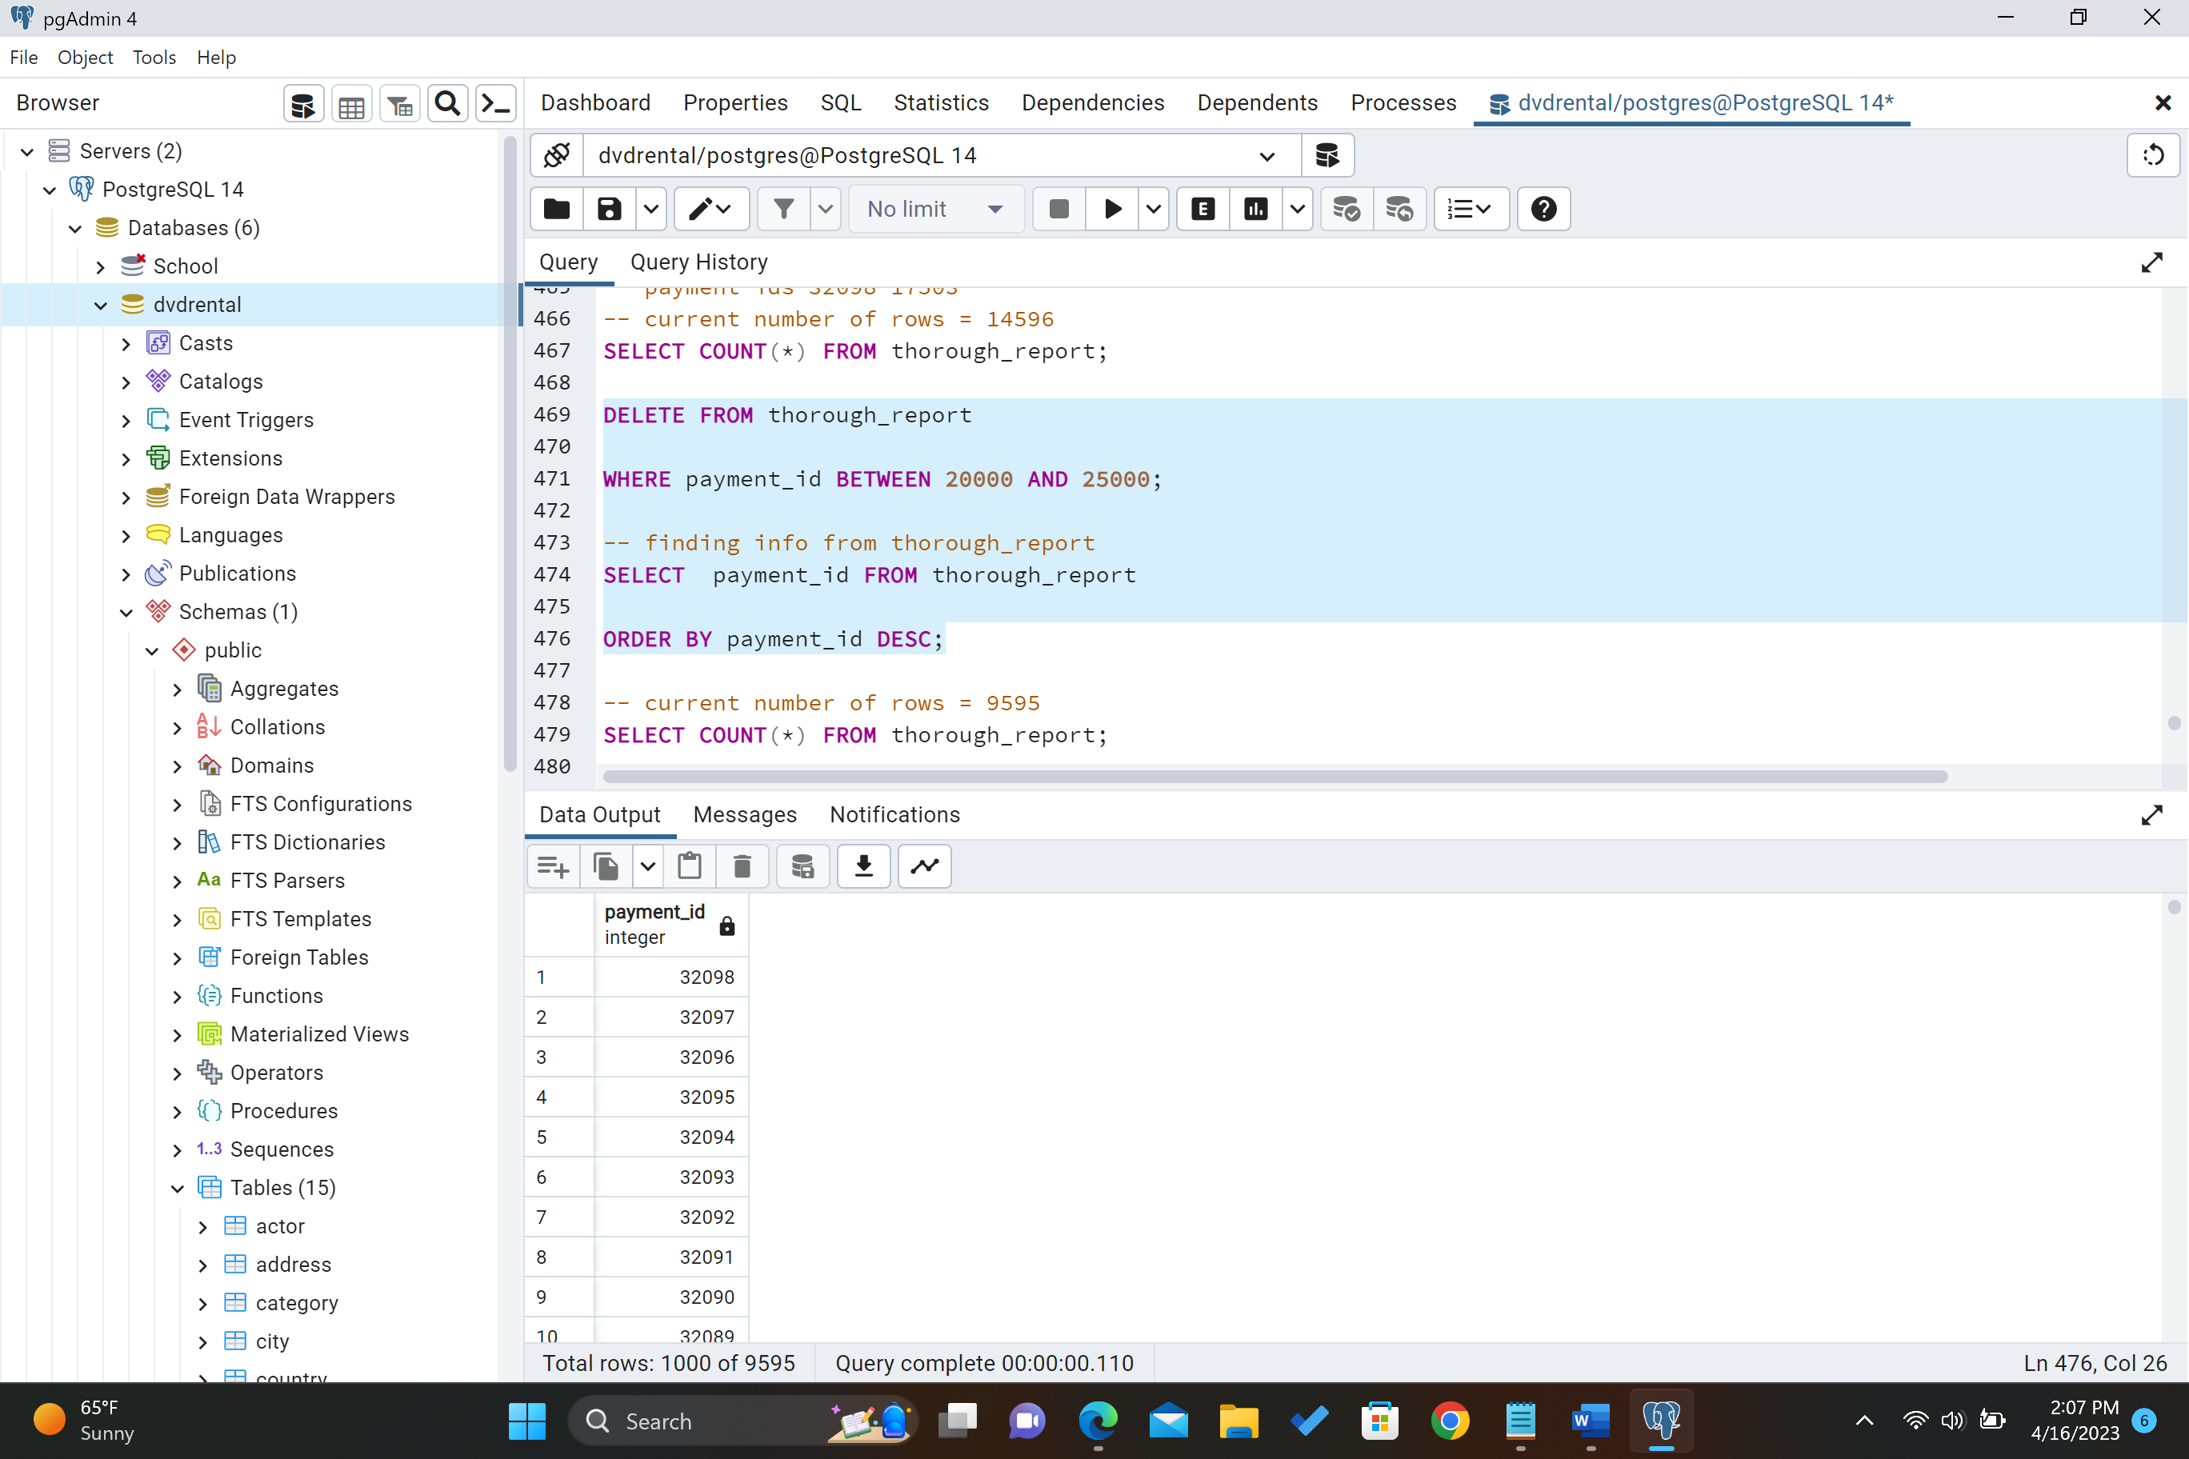

Below shows the current number of rows left now which is 9595.

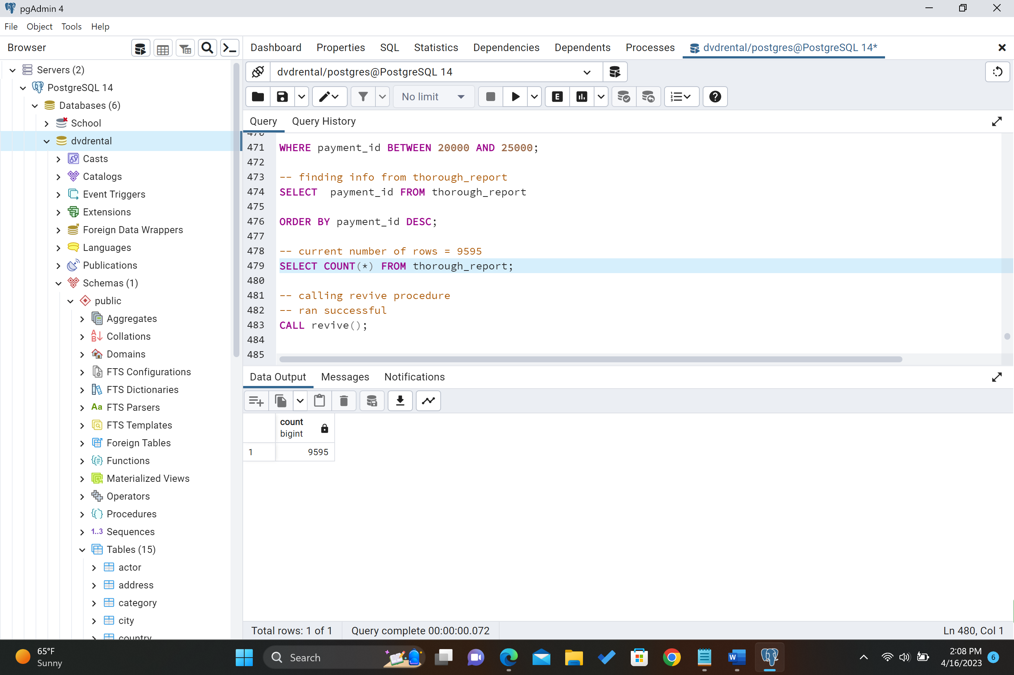

Below shows calling the revive procedure which was returned successfully.

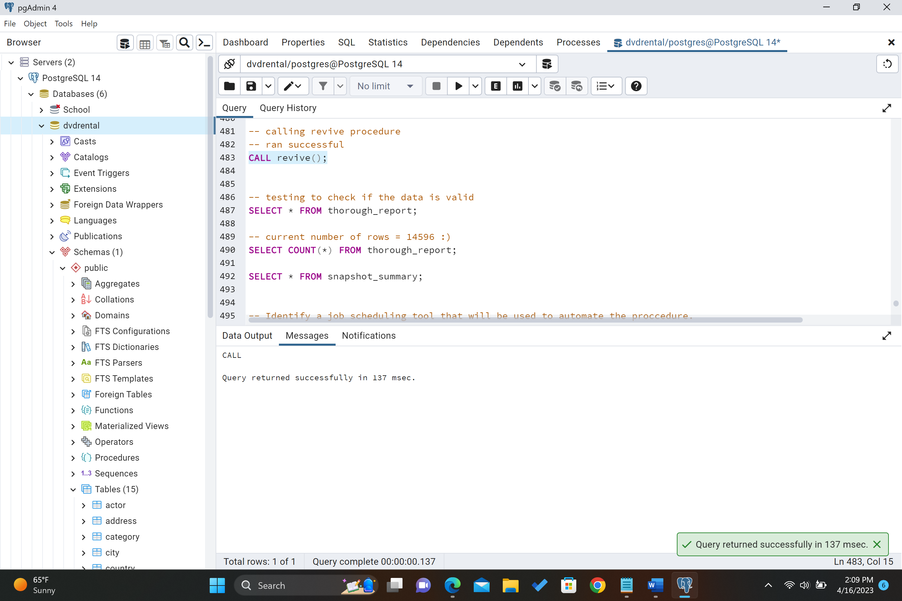

After calling the revive procedure the current number of rows is back to 14596.

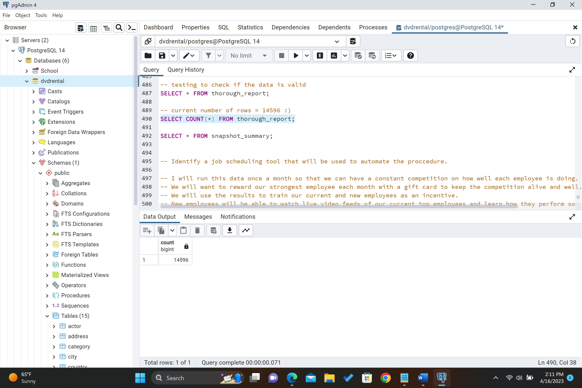

After calling both procedures thorough_report below.

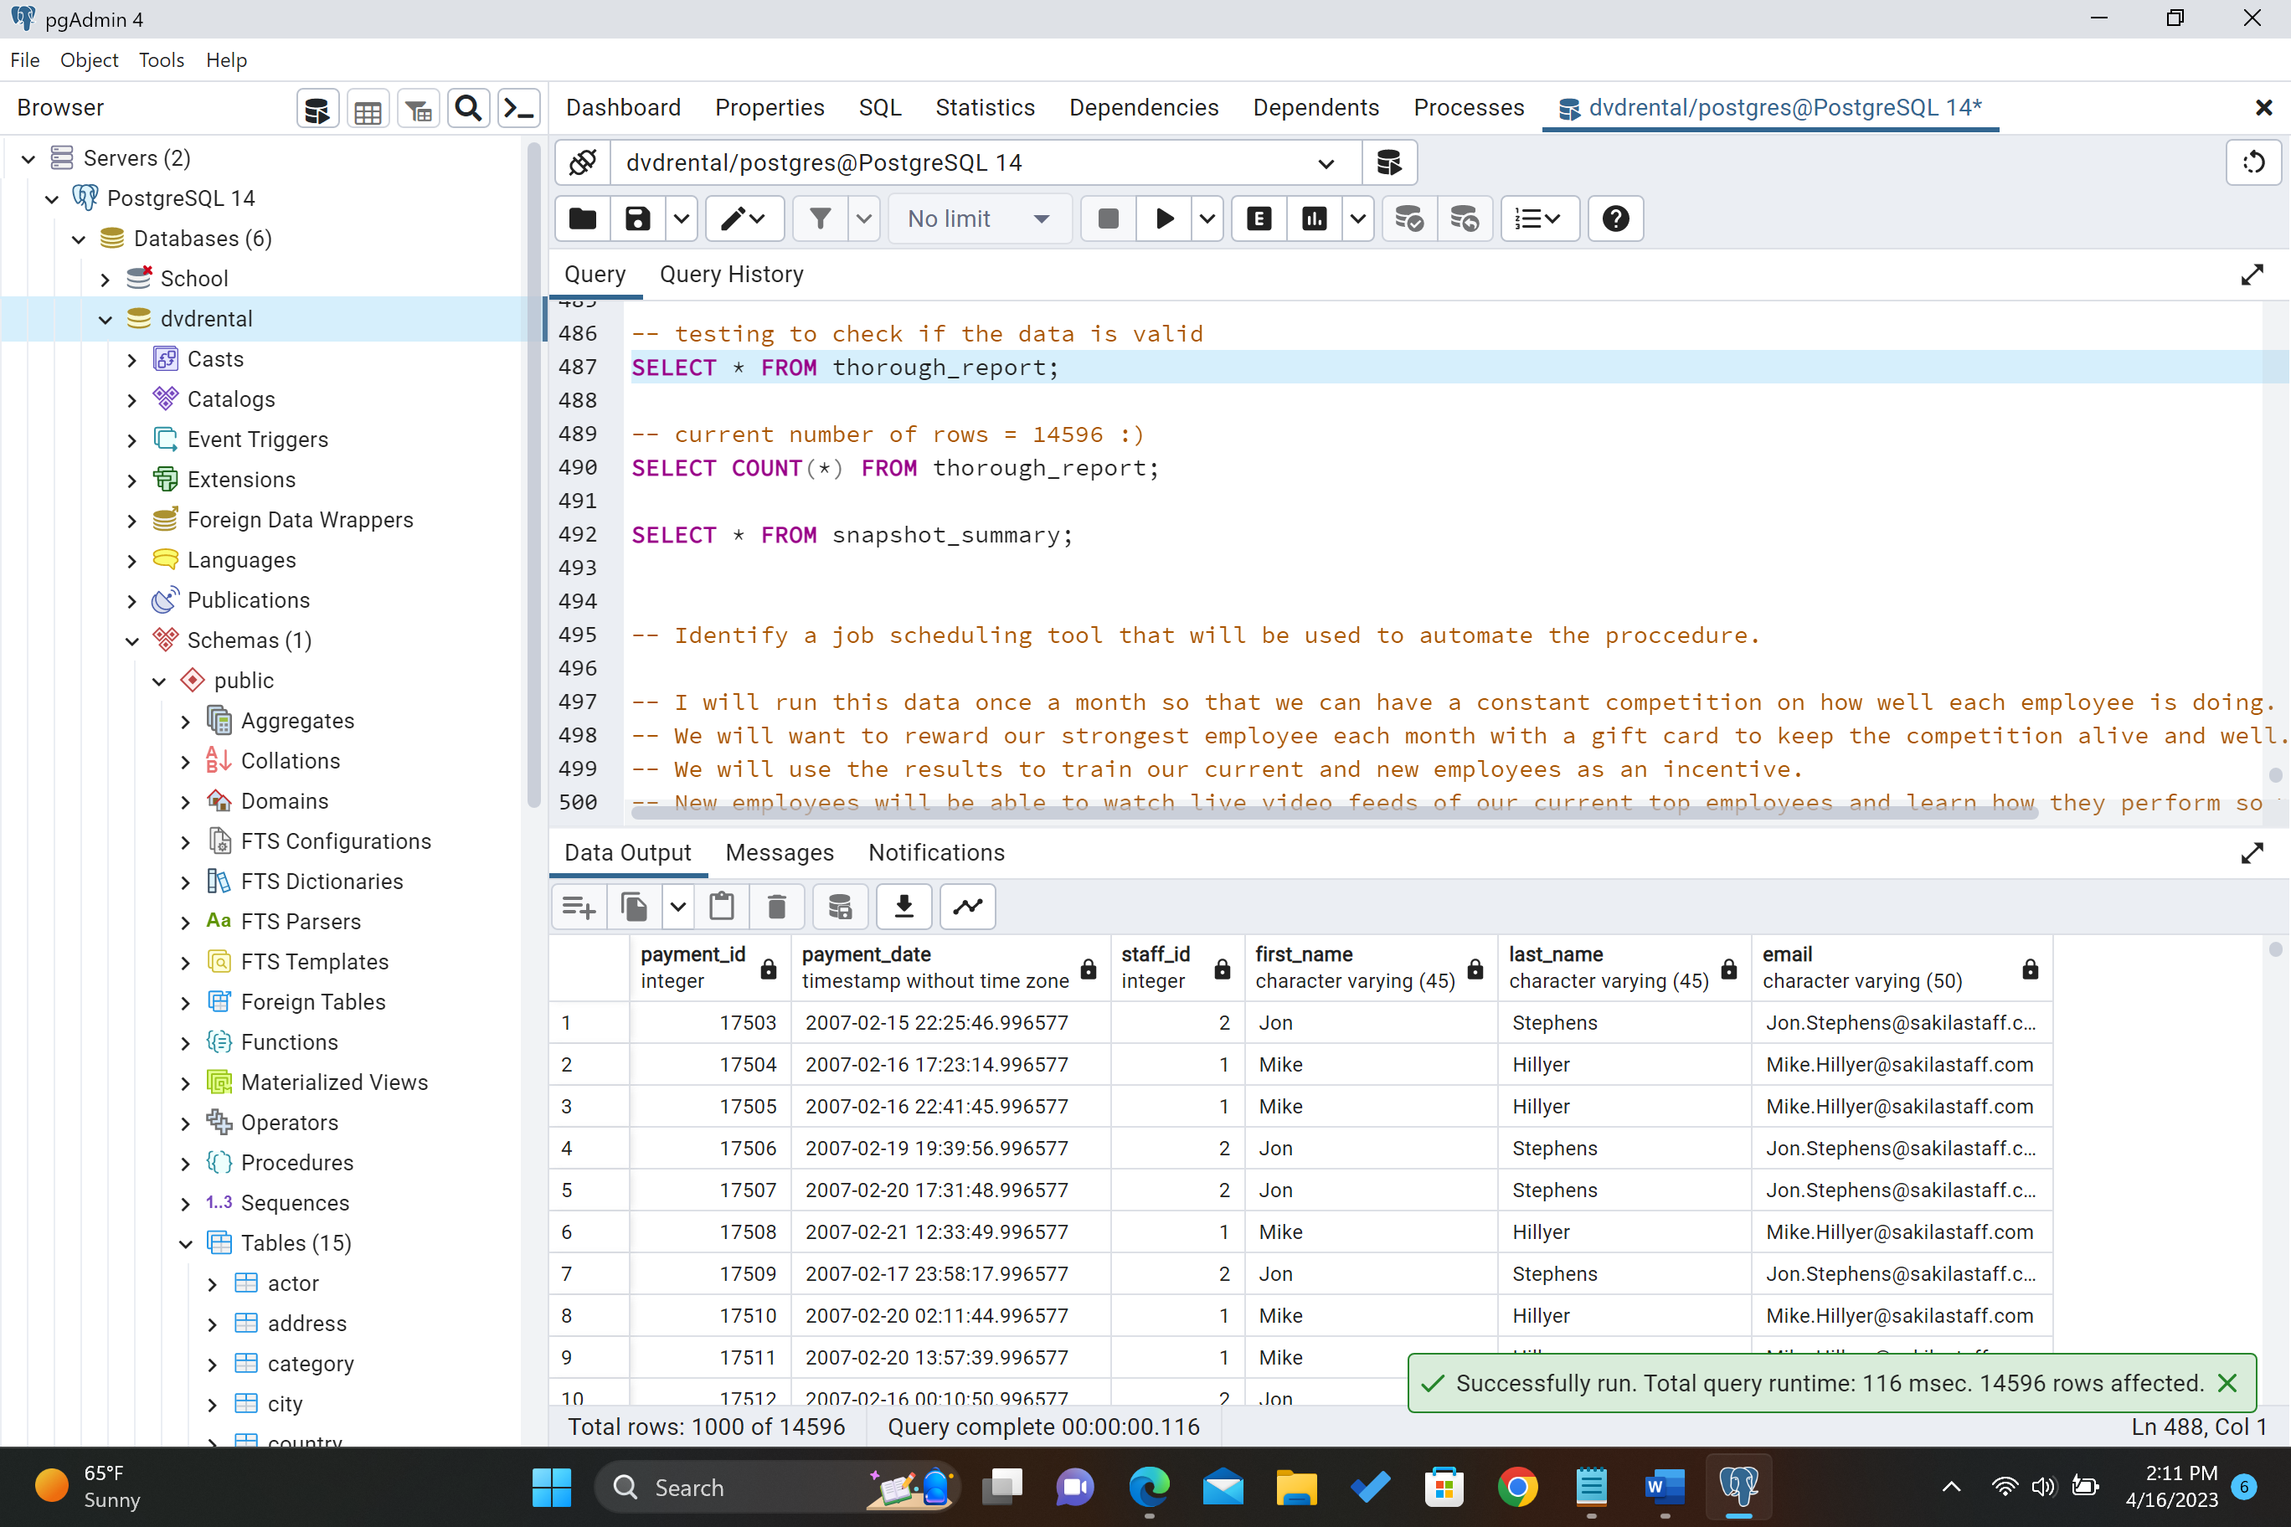

After calling both procedures snapshot_summary below.

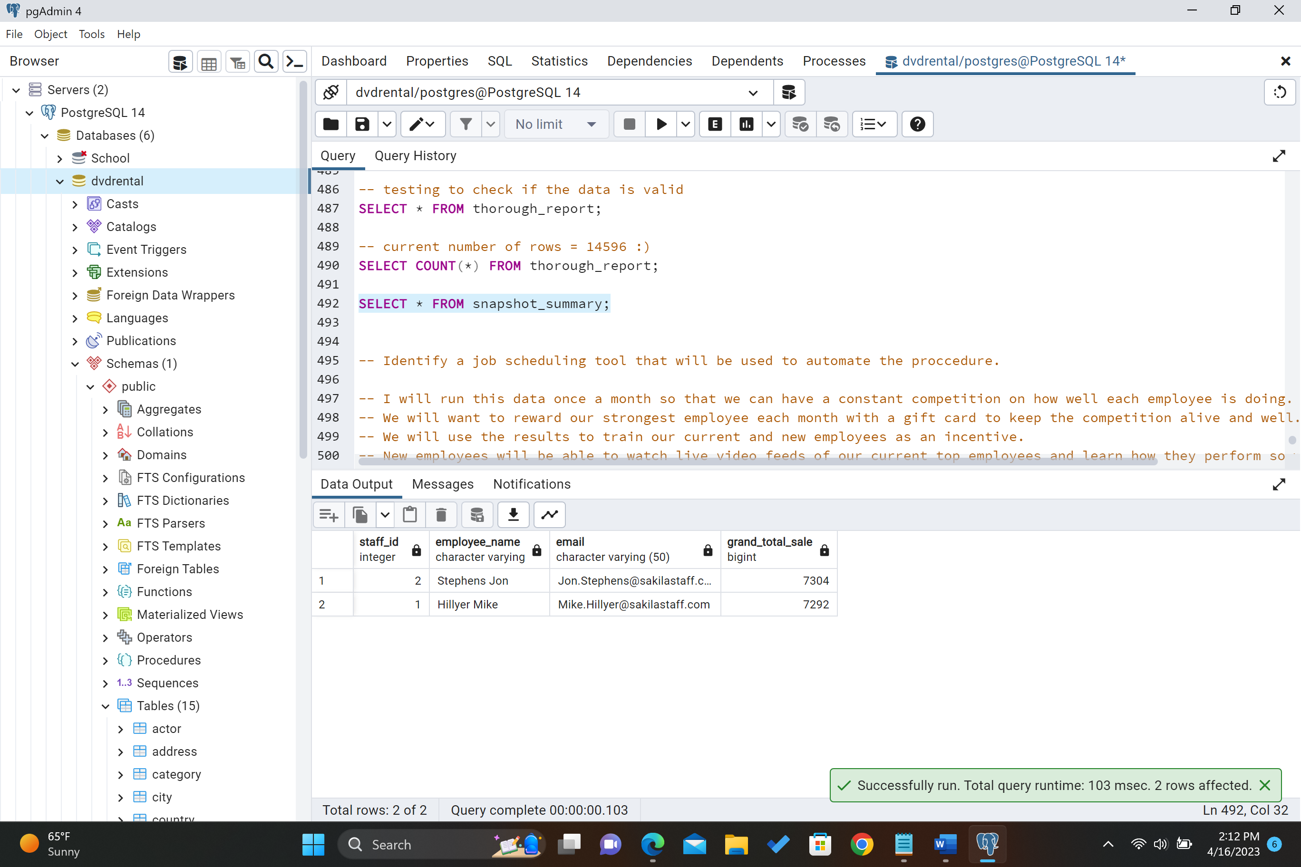

F1. Identify a tool for scheduling that can be used for automation and calling the stored procedure.

I will run this data once a month so that we can have a constant competition on how well each employee is doing. We will want to reward our strongest employee each month with a gift card to keep the competition alive and well. We will use the results to train our current and new employees as an incentive. New employees will be able to watch live video feeds of our current top employees and learn how they perform so well. We will use Agent pgAgent to schedule the monthly procedure to get the most current up to date data. This tool will call upon the procedure to refresh monthly so that we are seeing how well each employee is doing. We will also use this data to see if one employee isn't improving month per month to see if there is anything wrong. This will help our stakeholders know which employees we need to keep our eye on.

G. Panotopo Link of video

[D191 Panotopo Recording Business Question top employee (panopto.com)](https://wgu.hosted.panopto.com/Panopto/Pages/Viewer.aspx?id=a17481e6-9ff8-4e11-95ab-afe601621810)

H. Resources I used.

I didn’t use any outside resources.